|  |
| --- |
|  |
| IndoorGML Exporter Plug-in User’s Manual |
|  |

|  |
| --- |
|  |

Contents

1. AutoCAD to IndoorGML Exporter Plug-in 3

Installation and operation 3

Drawing review 3

Review layers and determine layer On/Off 3

Pre-processing 4

Create layer 4

GML-bldg-pdoor Pre-Processing 6

GML-bldg-cs Pre-processing 7

GML-bldg-gap Pre-processing 7

IndoorGML 설정 8

Room Detection ( Room boundary Detection) 10

Settings 10

Room Detecting 11

If the room cannot be detected 12

Room Delete 14

Clear/Load 15

Enter Room Class and Function information 16

Define Room Class and Function 16

Understanding the Class and Function 16

Set default Class and Function 17

Combining 18

Log Review 19

2. Revit to IndoorGML Exporter Plug-in 20

Installation and operation 20

Model review 20

Enter Room Class and Function 21

Exporting 22

3.IndoorGML Editor 23

IndoorGML File Review 23

Edit 23

Move State Function 24

Path Edit 25

Create Transition 26

Cell Space Data Table – Building energy information visualization 27

Data Table Setting > Cell Space 27

Cell Space Data Table in the main app window 28

Transition Data Table 30

Data Table Setting > Transition 30

Transition Data Table in Main window 32

Guide for Editing exported IndoorGML Excel 34

Considerations 35

# 

# 1. AutoCAD to IndoorGML Exporter Plug-in

## Installation and operation

When running AutoCAD after installing AutoCad to IndoorGML_vx.exe, you can find IndoorGML ribbon menu is installed as shown in the figure below. Press the Exporter button to run IndoorGML Exporter.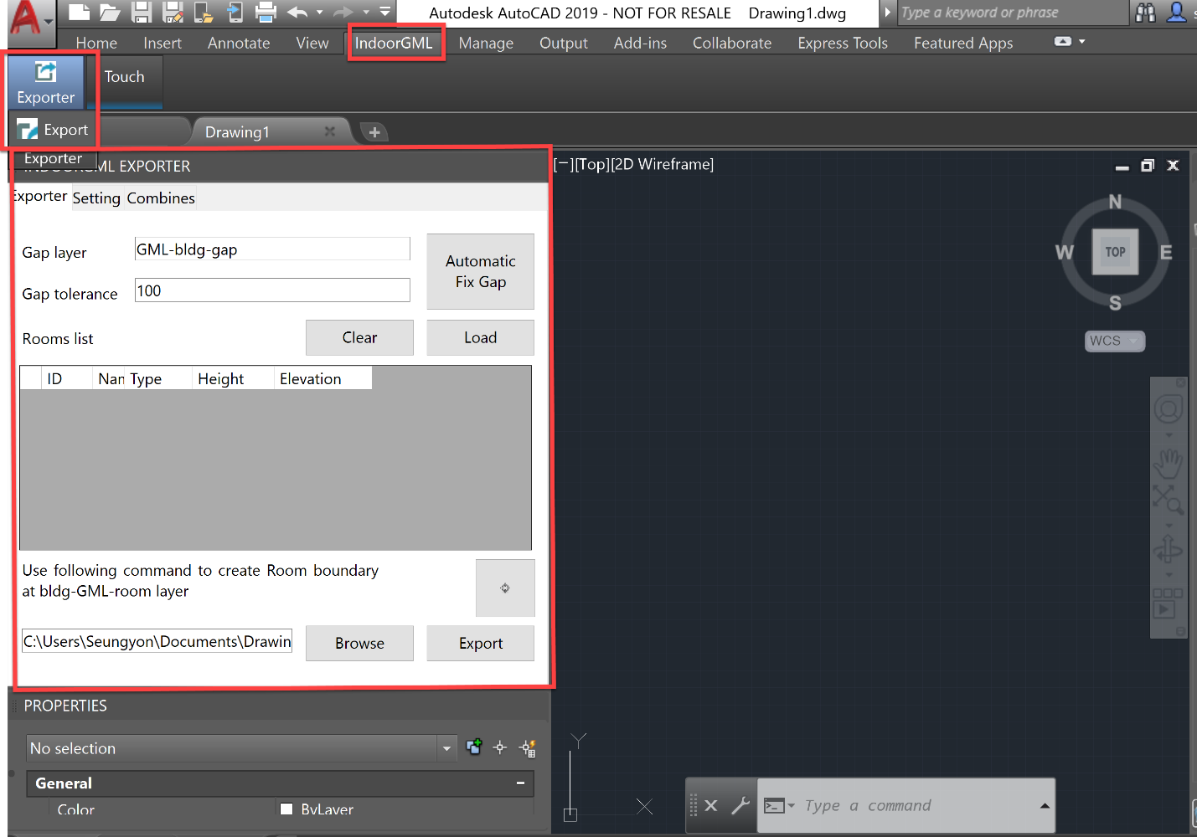

## Drawing review

### Review layers and determine layer On/Off

Open the drawing to be exported to IndoorGML and review the layers. Since the core function is to detect Room Boundary and export it to IndoorGML, focus on the WALL, COLUMN, WINDOW, SECTION, and DOOR layers and turn on the appropriate layers for Room Boundary detection.

The layers to be turned on will be different depending on the layer naming in the drawing. While detecting Room Boundary, you can perform detection function by selectively turning on/off the layer.

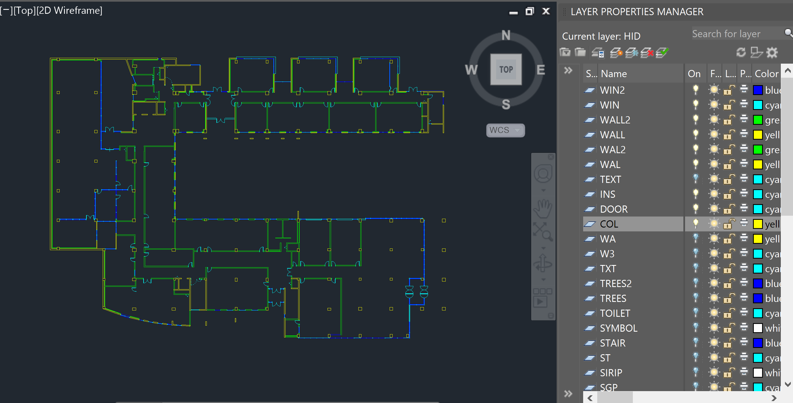

## Pre-processing

In this step, layers to be used as auxiliary layers for indoorGML exporting are created, and complementary work is performed to facilitate the detection of Room Boundary in the program.

### Create layer

Create GML-bldg-pdoor/ GML-bldg-cs/ GML-bldg-gap to be used for pre-processing and GML-bldg-room to store the detected Room Boundary information. The role of each layer is as follows.

|  |  |  |  |
| --- | --- | --- | --- |
| IndoorGML Layers | Usage | How to User | 비고 |
| GML-bldg-pdoor | Room cannot be detected by turning on the Door Layer(geometry drawn as Door) in AutoCAD. Therefore, instead of the Door layer, draw a rectangle at the door position on this layer and treat it as a door attached to the room. | Create a layer and draw a rectangle at the location of the existing door. |  |
| GML-bldg-cs | It works like Revit's Room Separator, and is extracted as Cell Space Boundary in IndoorGML. | Create a layer, and draw a line at the space separator like Revit's Room Separator. |  |
| GML-bldg-gap | It is used to block the unclosed space during Room Boundary detection. | Create a layer, and when it detects a gap, by drawing a line to fill the gap, it closes the gap in this layer. |  |
| GML-bldg-room | It is used to save the detected Room Boundary. | Create a layer.  Room Boundary is automatically saved when room is detected, and it can be used to manually create Room Boundary. | Save detected room information |

Layer creation is created at once by using the **[Create]** button in the setting below. 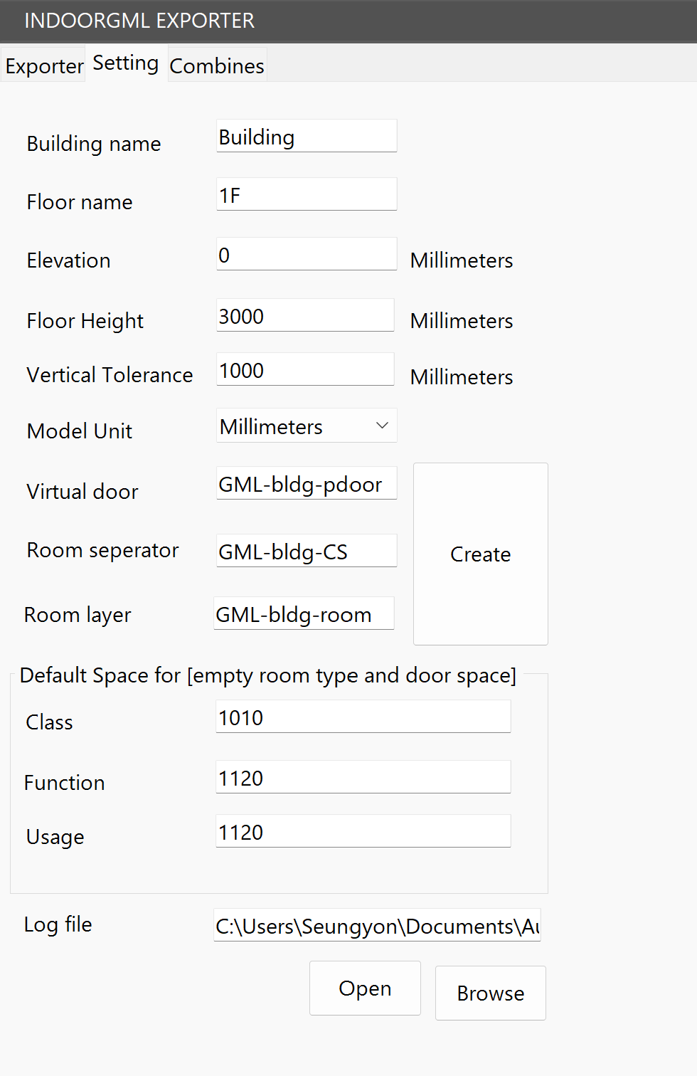

#### After entering preprocessing layers

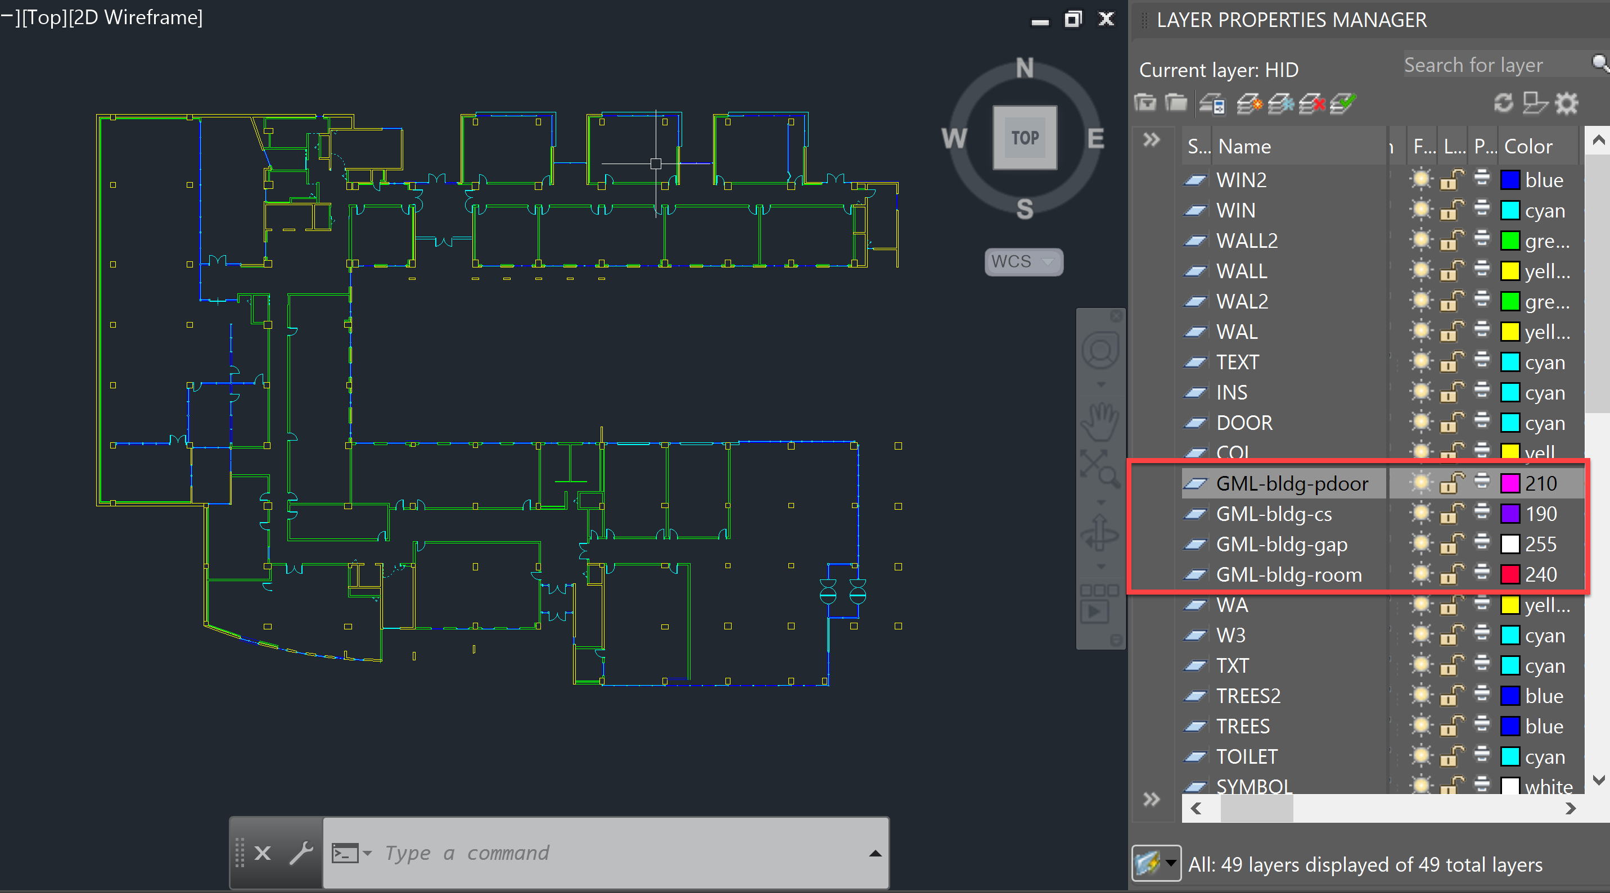

Tip: When entering a layer, it is convenient to separate the colors into different colors.

### GML-bldg-pdoor Pre-Processing

Draw the rectangle to be extracted as the door that is attached to the room when exporting the room boundary.

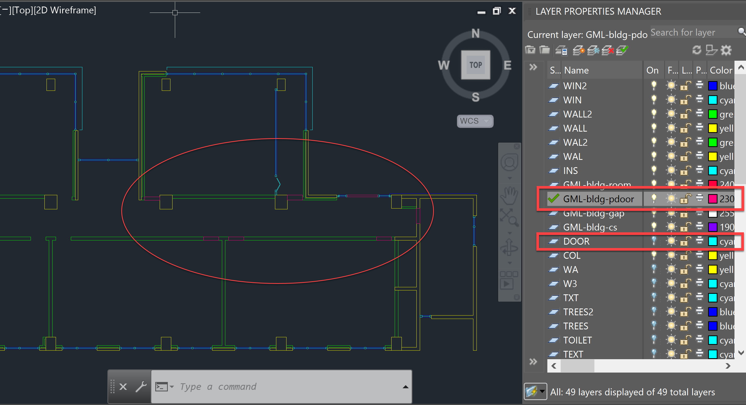

As shown in the picture above, set GML-bldg-pdoor as the Current Layer (green check mark) and draw a rectangle at the door position. (At this time, the Door layer of the original drawing is off. If necessary, turn on/off and proceed with the work.

### GML-bldg-cs Pre-processing

If it is not separated by a physical wall but needs separation of space, draw a line on the GML-bldg-cs layer like Revit's Room Separator as shown below. (Purple line)

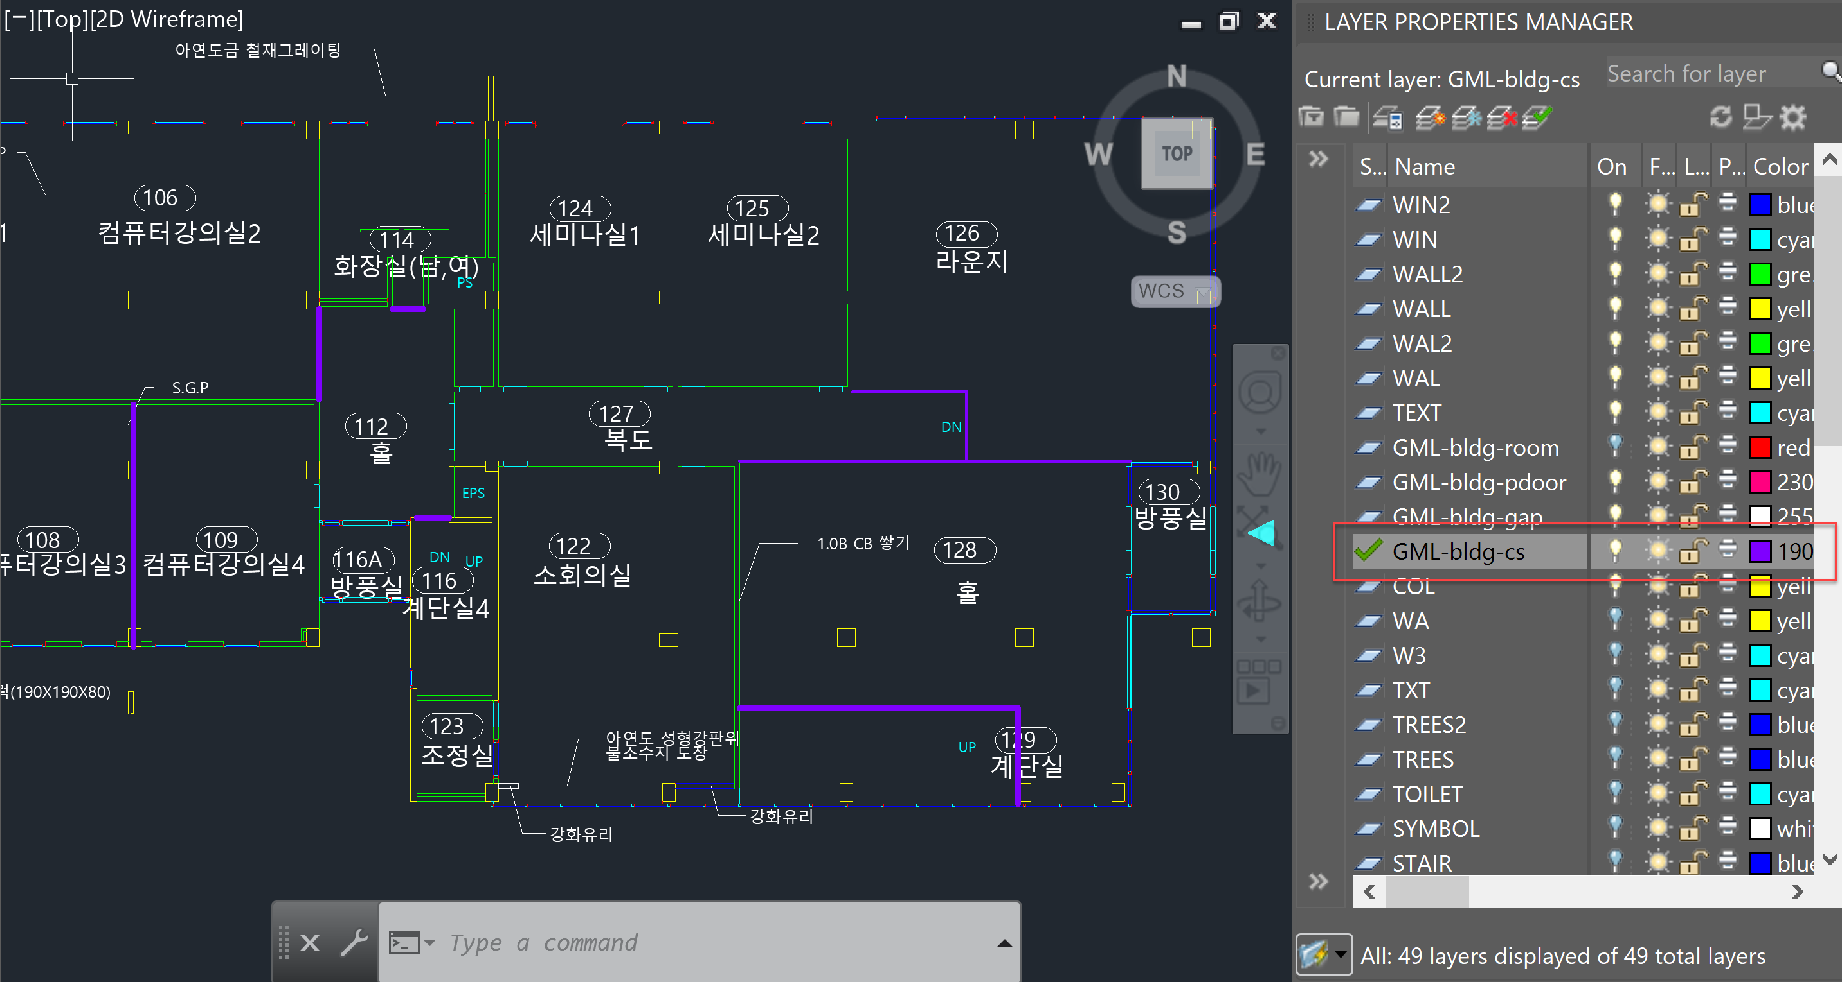

### GML-bldg-gap Pre-processing

Even if necessary, layers are turned on, if there is a gap and the room cannot be detected, draw a line on this layer to block the gap.

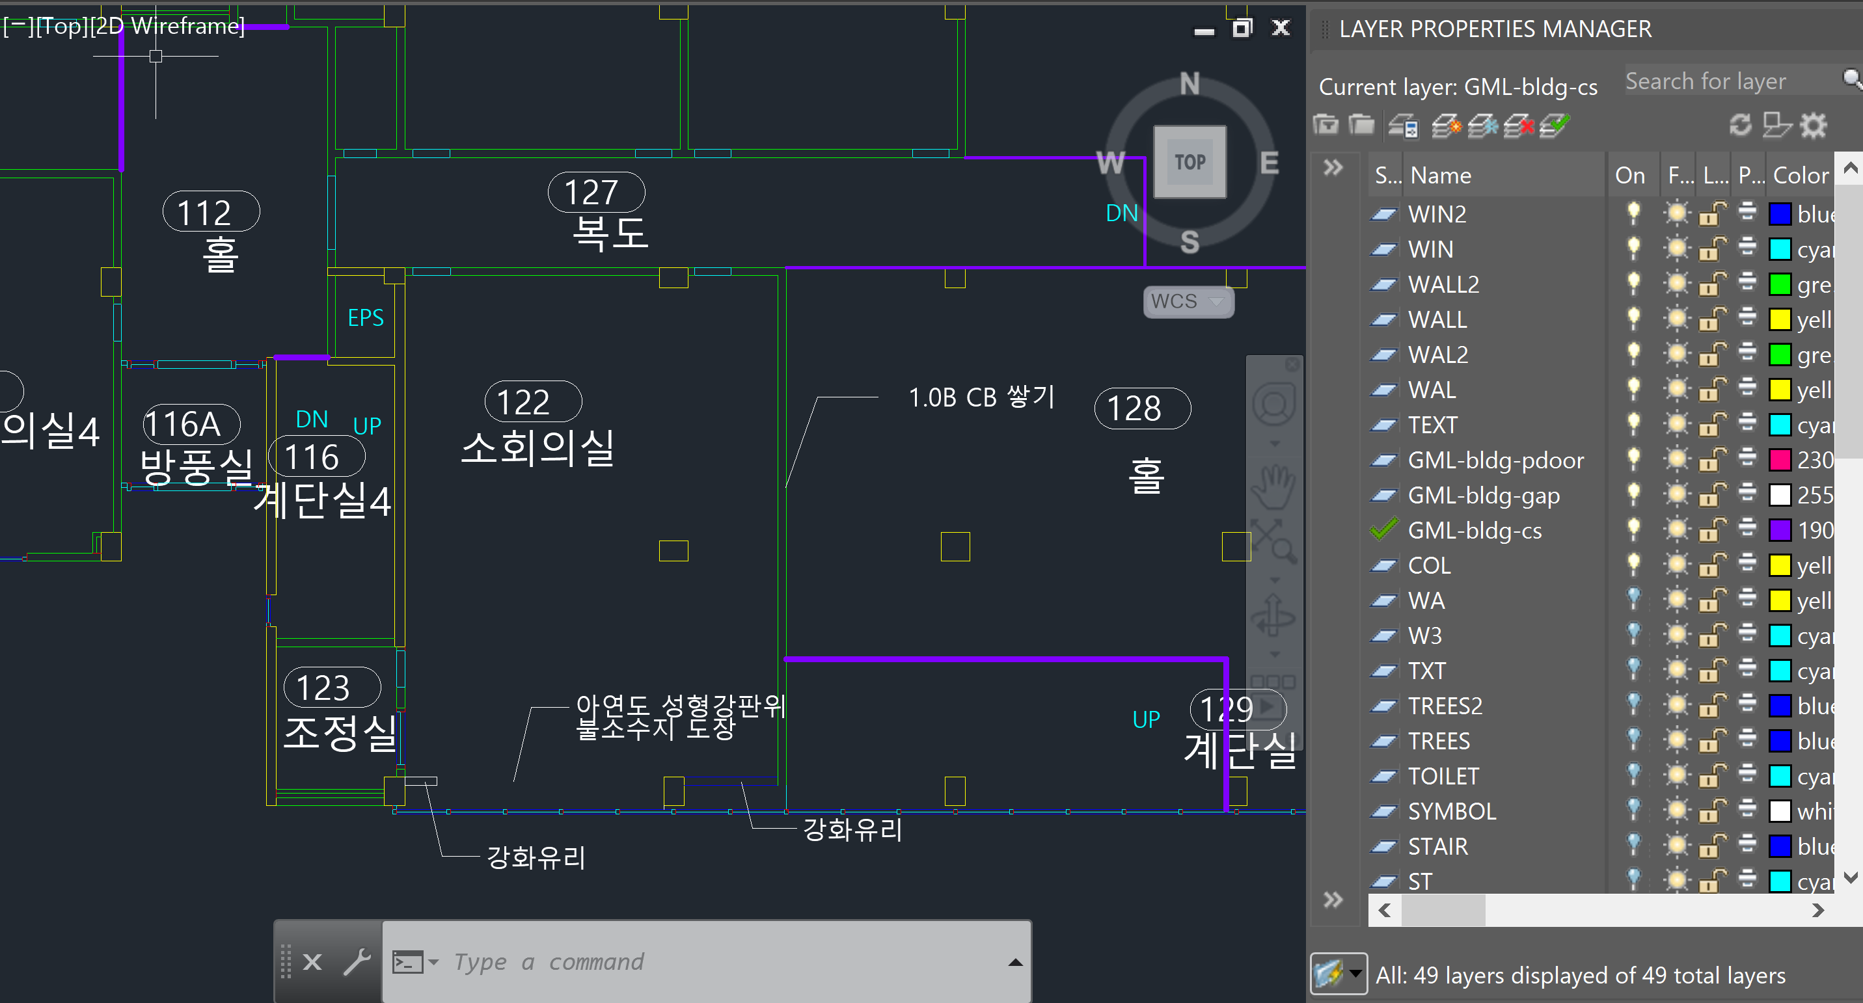

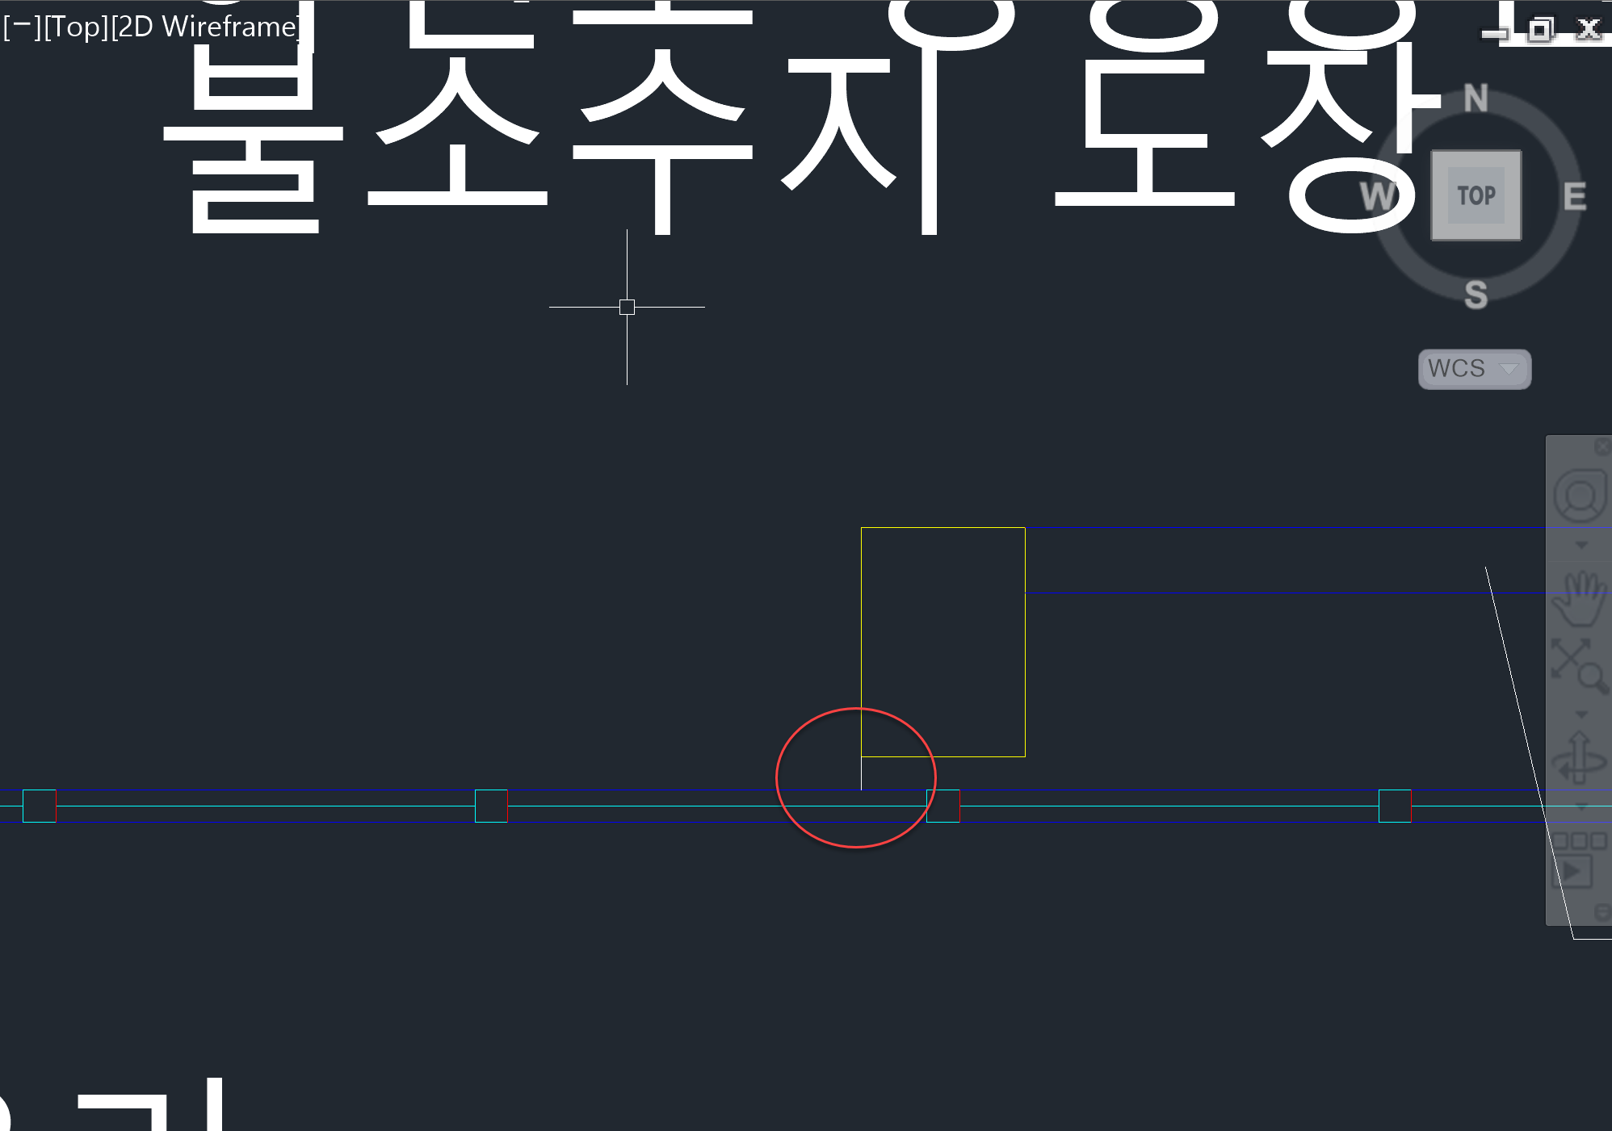

If you have pre-processed 3 layers, the pre-processing process is over, and now it goes to room detection.

## IndoorGML Settings

|  |  |
| --- | --- |
|  | In the Setting tab, set the name of the log file location. |
|  | In the Exporter tab, set the storage location and IndoorGML file name.  Click the Export button to extract the IndoorGML file. |

When the extraction is complete, the Indoor Editor runs and you can review the IndoorGML extraction results as shown below.

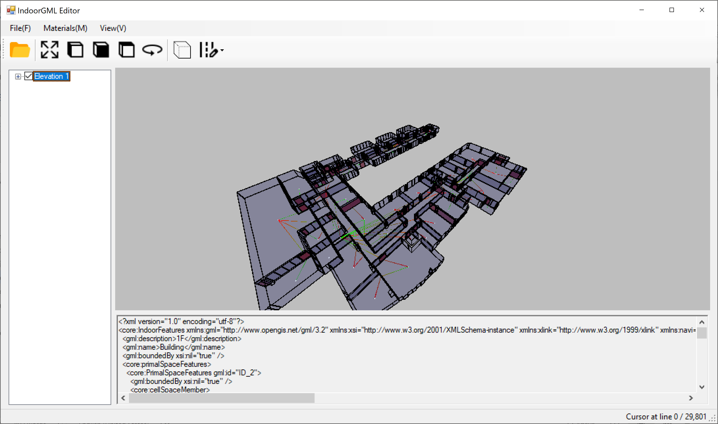

## Room Detection (Room boundary Detection)

### Settings

Before room detection for each drawing, make the following settings.

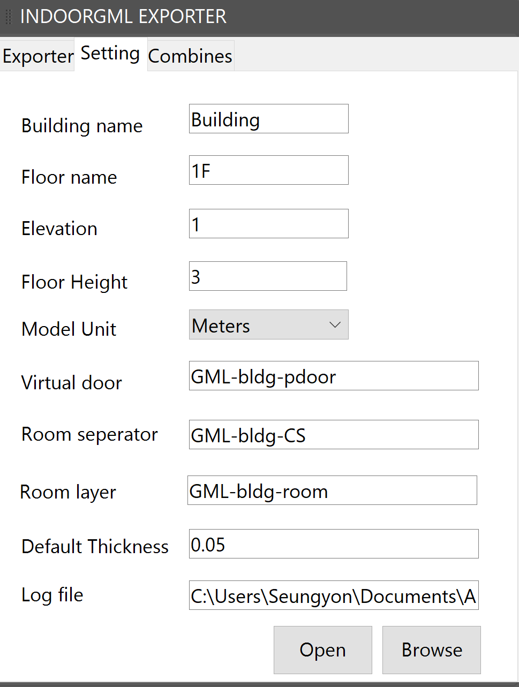

|  |  |
| --- | --- |
| Setting Values | Description |
| Building Name | Name entered as building name in IndoorGML |
| Floor Name | Enter the floor name. |
| Elevation | Enter the elevation information for that layer.  When combining, the combination is processed based on the Z axis according to this elevation value. |
| Floor Height | This is the default Height value of the room, but it can be set for individual rooms in the Exporter. |
| Model Unit | Set the Model Unit. The default value is Meter. |
| Virtual Door | Instead of the actual door layer entered above, enter the layer name for the auxiliary door layer name in IndoorGML.  In this example, it is GML-bldg-pdoor. |
| Room Separator | This is a layer setting that enables space separation such as Room Separator.  In this example, it is GML-bldg-cs. |
| Room Layer | Room Boundary detected through Room detection is saved.  In this example, it is GML-bldg-room. |
| Default Thickness | Cell space thickness setting applied in IndoorGML. |
| Log File | Set the log file name and storage location to report the extraction results. |

### Room Detecting

After completing the above settings, you are ready to detect Room.

Turn on the layers to be detected in the room (the original Door layer needs to be Off)

1. Click the button
2. Click on the Room spaces in the drawing one after the other. 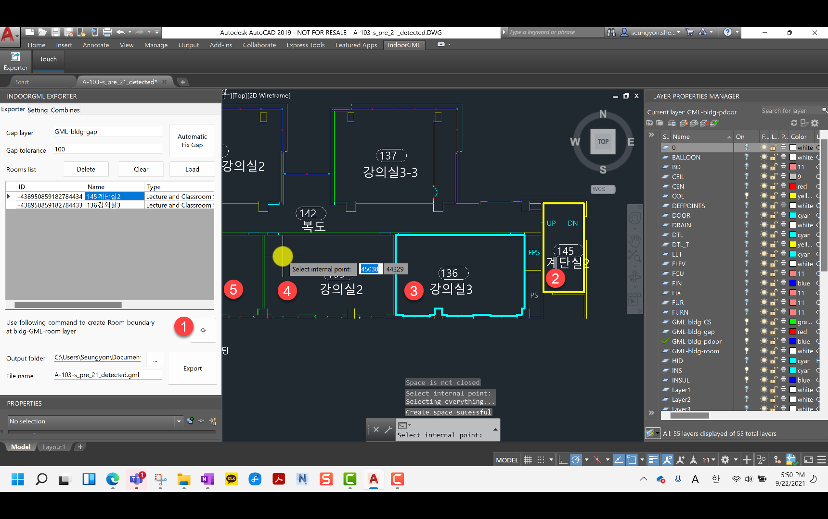

As shown below, a room is created in the Room List, and the Room Boundary is also entered on the drawing.

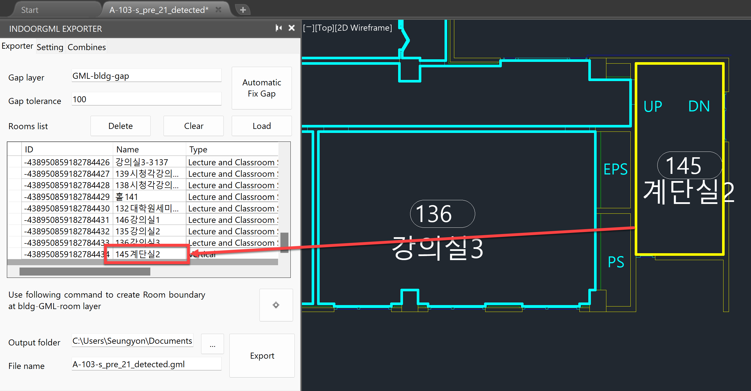

Repeat steps 1 and 2 above to detect the entire room in the drawing.

### If the room cannot be detected

#### 1. Space is not closed

If the space is not closed as shown below, it cannot be detected. Draw a line on the GML-bldg-gap layer to block the space,,

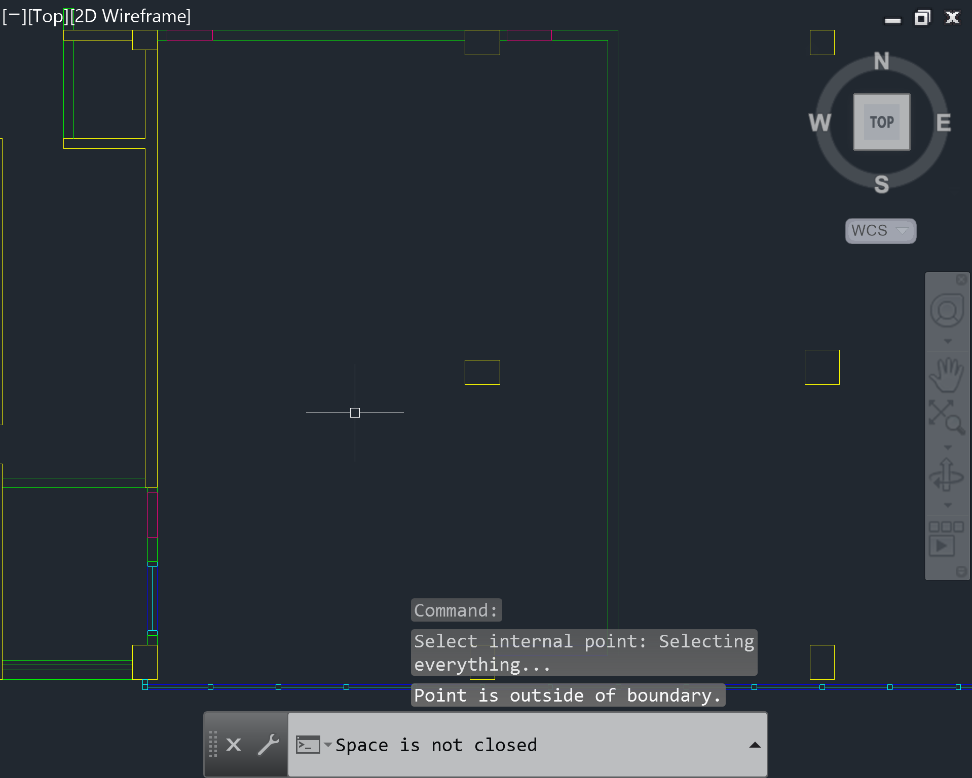

Close the gap as shown below and detect again.

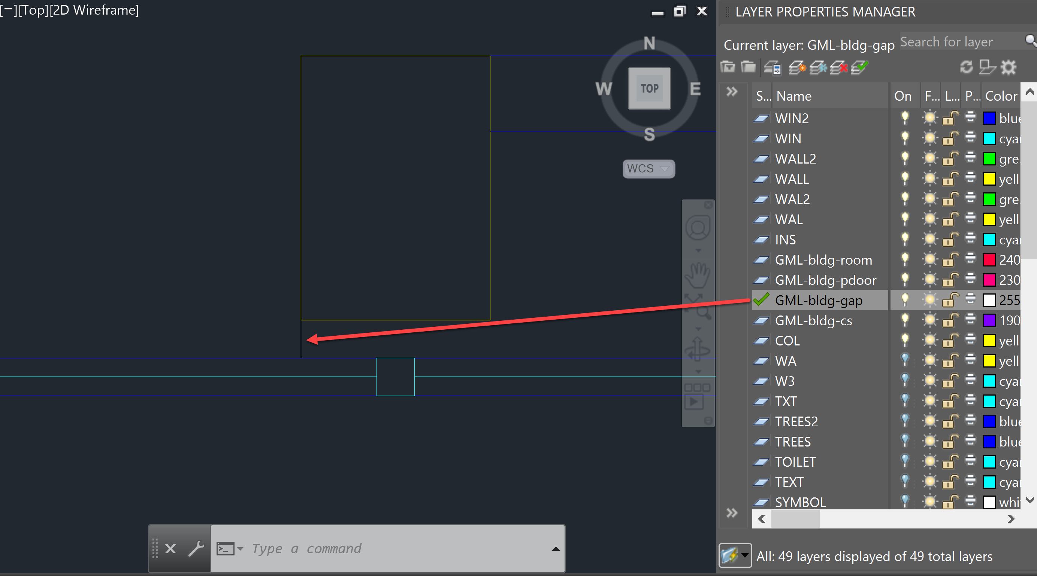

#### 2. If the space is blocked but not detected at once, try changing the click position.

It may not be detected at once, such as the space below (yellow highlighted). In this case, please attempt the detection by changing the detection point (click point).

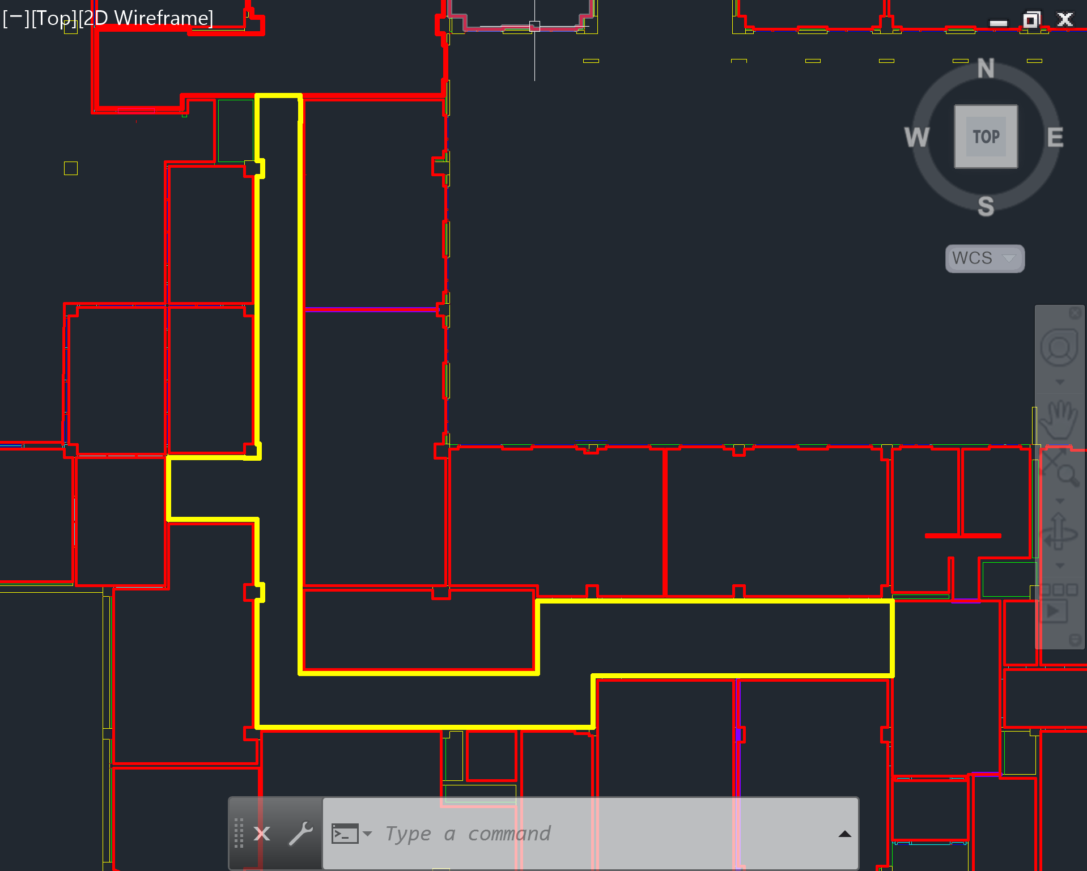

#### 3. If the space to be detected is cut off on the graphic screen

Make the space displayed on the screen as shown on the right, and then perform detection.

|  |  |
| --- | --- |
| Not Detected | Can be detected |
|  |  |

#### 4. When the above method is applied, but detection is not performed

Draw the room boundary yourself.

1. Set GML-bldg-room to Current Layer
2. After selecting Draw> Polyline,
3. Draw a Polyline along the room boundary as shown below. (Red highlight line)

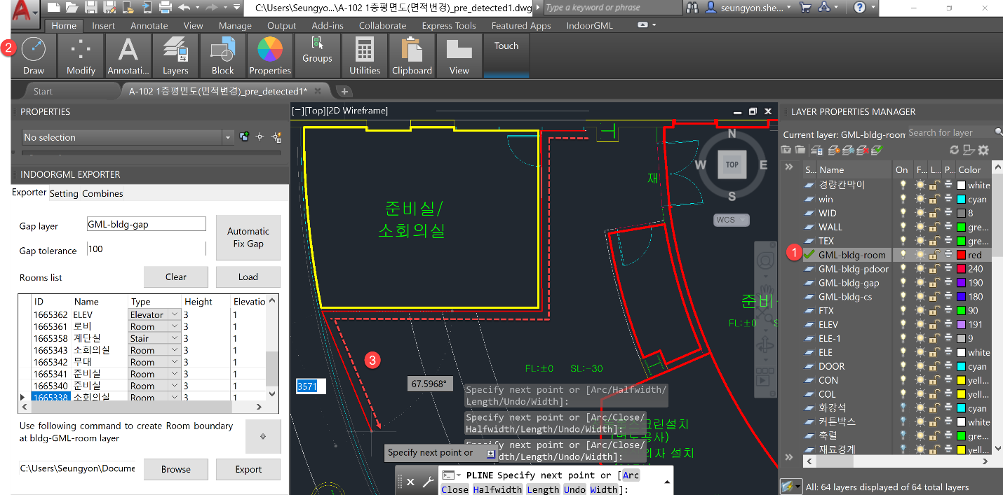

1. Clicking the Load button
2. The newly created Room appears in the Room List.

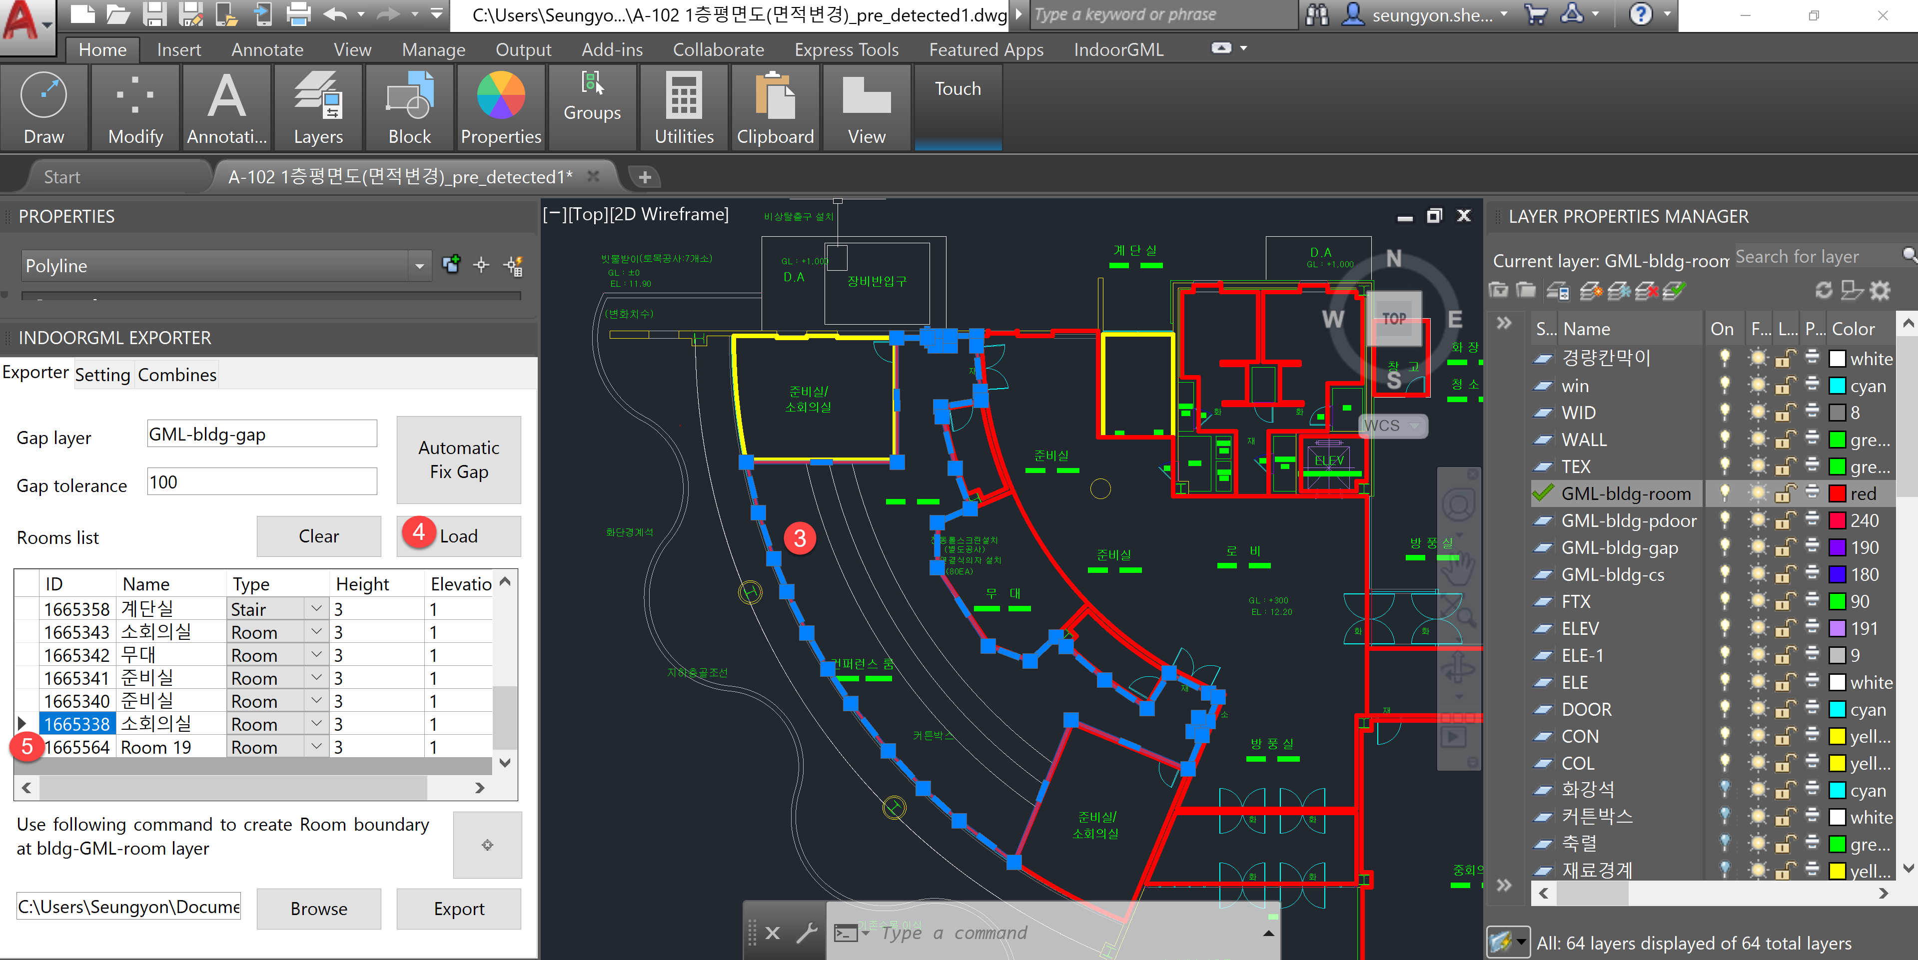

### Room Delete

Select the room from IndoorGML Exporter's Room List and press the “Delete” key. It disappears from the graphic as soon as you press the Delete key.

Caution: Delete from the Room List, not from the graphic window.

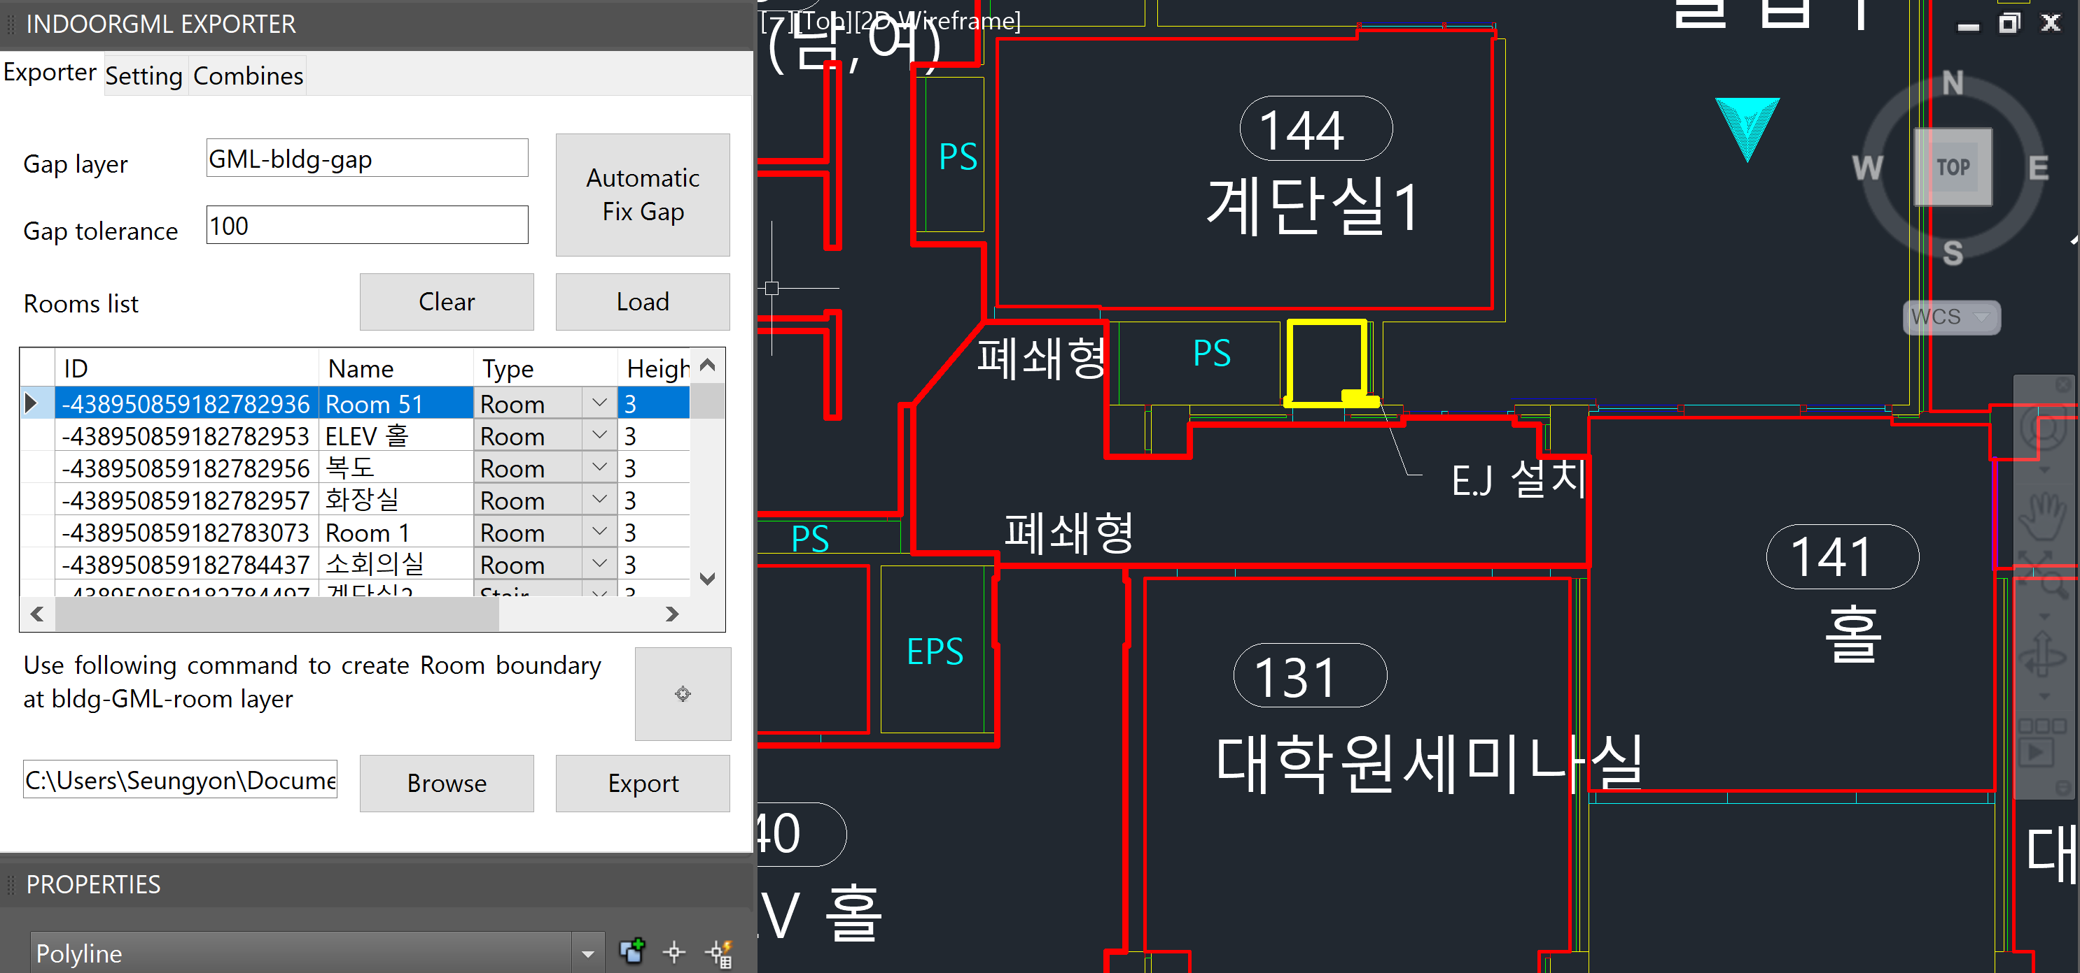

### Clear/Load

The information in the Exporter window is linked to individual DWG file. If it is not the current drawing information, press the Clear button to delete the information, and to read the current drawing information, press the “Load” button to load the Room List information.

If you want to continue working by reopening the drawing that has previously detected a room in AutoCAD, click the “Load” button to load the Room list and continue working.

## Enter Room Class and Function information

### Define Room Class and Function

After detecting a room, modify the Cell Space Class Type and Function to suit the room.

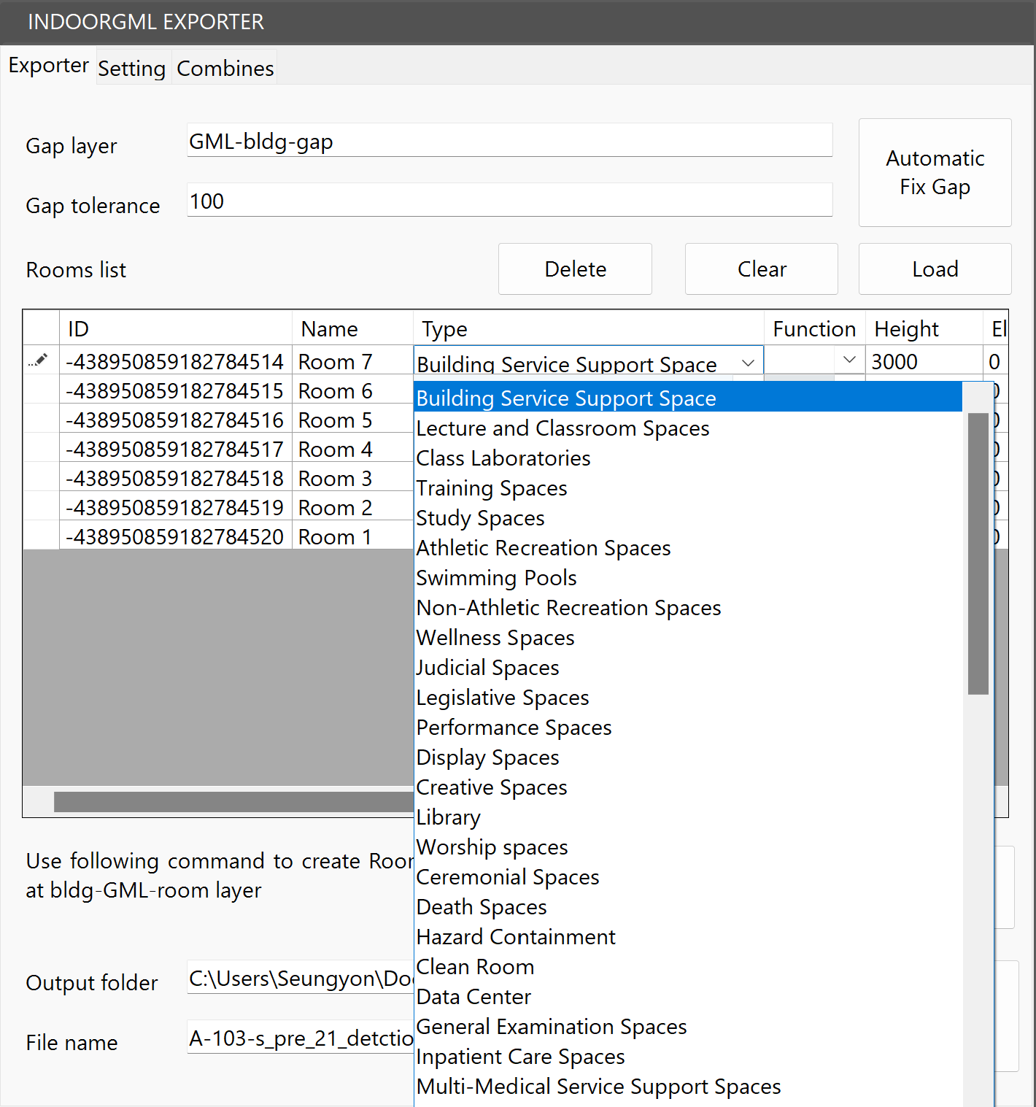

### Understanding the Class and Function

It is based on the Excel table taken from the Class and Function list of Cell Space.

File Location: C:\Program Files\Autocad2IndoorGML\Config\unitSpaceClass and Function Code.xlsx

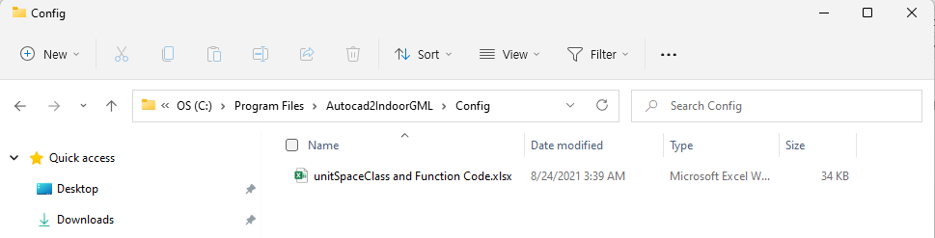

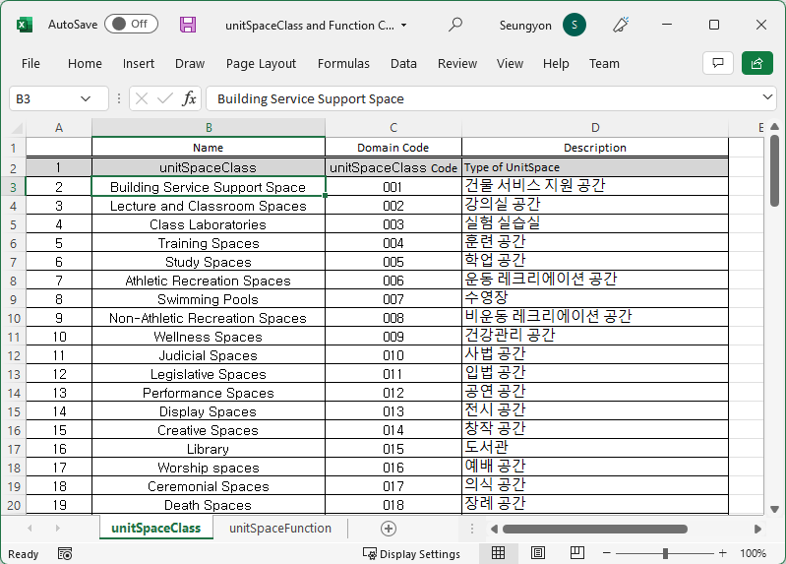

* Above excel refers to A.5. Code list of unitSpaceClass attribute and , A.6. code list of unitSpaceFunction property of 2021PG409-013 IndoorGML Data Model(Draft)_202100625.hwp

### Set default Class and Function

When a room is detected, the class and function are set that are input by default.

After room detection, Class and Function can be modified according to the purpose in the Exporter screen.



## Combining

In the case of AutoCAD, it is extracted as each IndoorGML file for each DWG drawing (by floor), so after extracting individual floors, add files using Combining, and then merge them into one building model.

|  |  |
| --- | --- |
|  | Click the “Add” button to add the extracted XML files for each layer. If the elevation value for each drawing (by floor) does not match or overlap, the spaces overlap or become farther apart, so be sure to accurately input elevation information when working on each floor.  When all the files to be combined are loaded, click the “Combines” button to convert them into one XML file. |

## Log Review

The indoorGML extraction result is recorded in a log file, and you can check the setting information, the number of rooms/doors, and the extraction time.

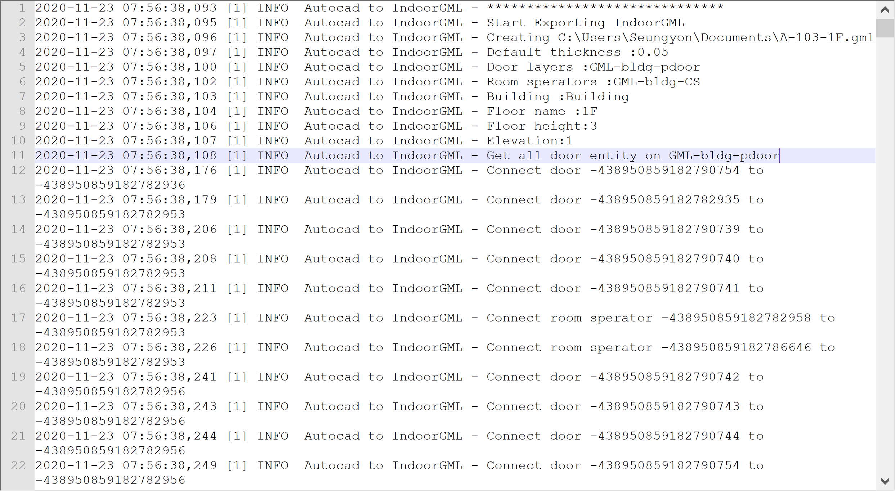

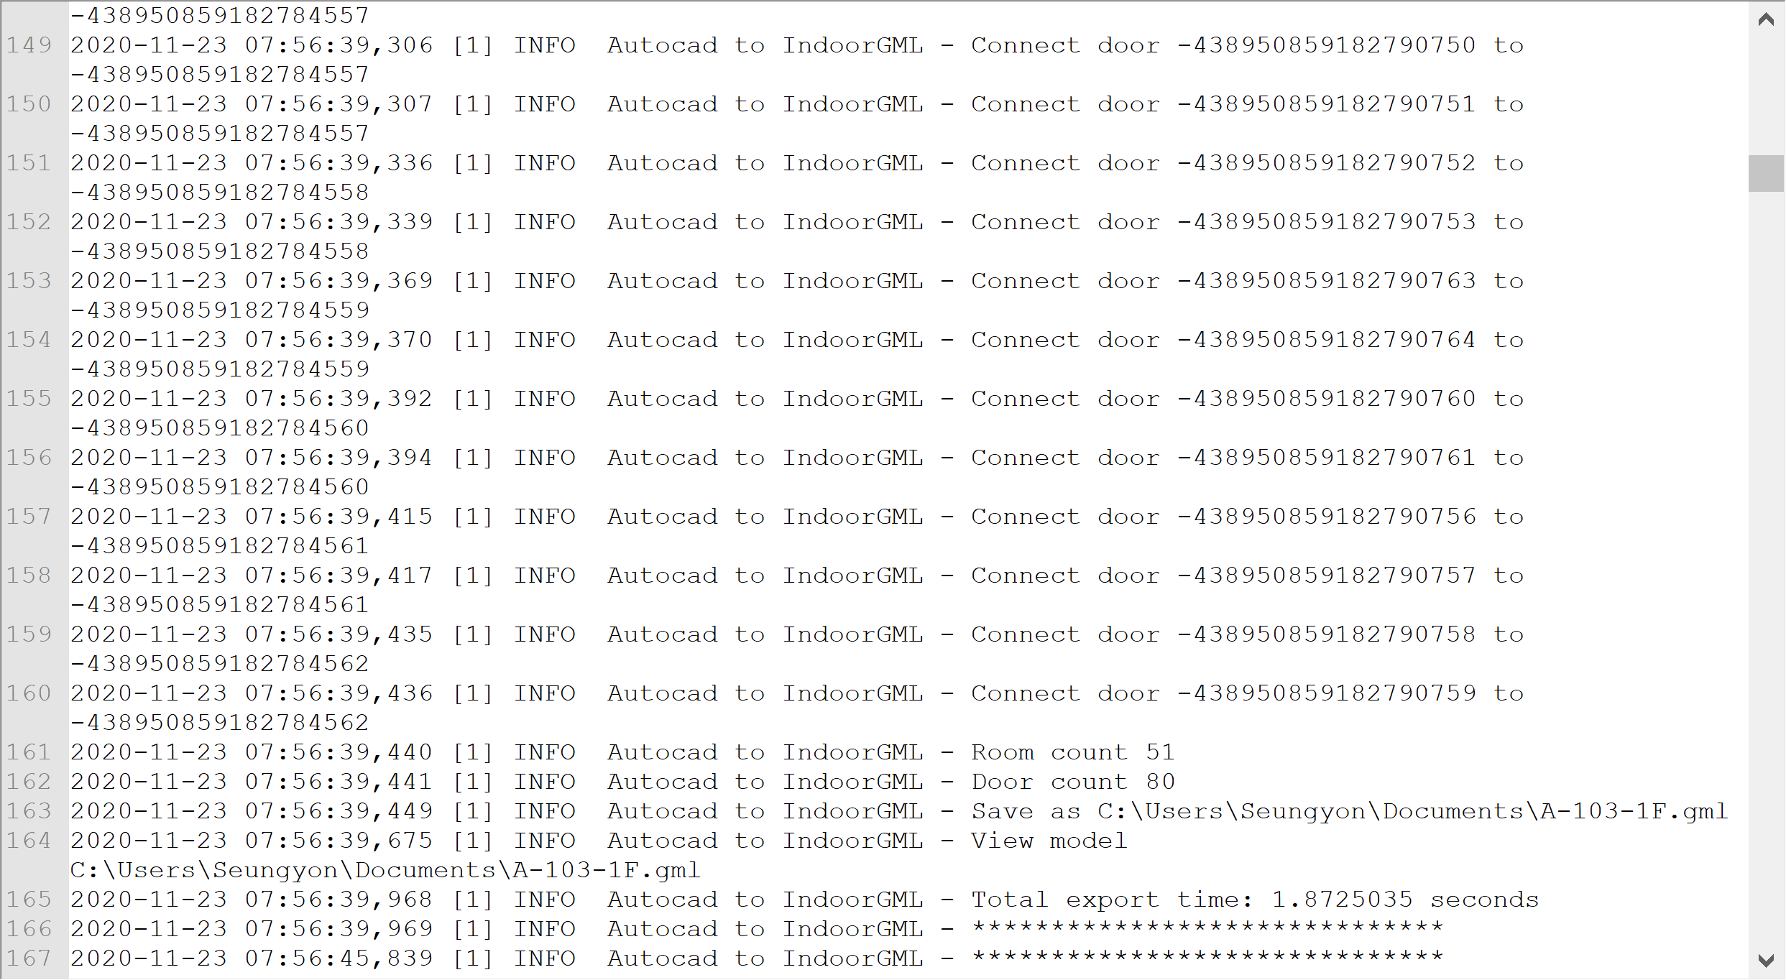

# 2. Revit to IndoorGML Exporter Plug-in

## Installation and operation

After installing Revit to IndoorGML_vx.exe, you can find IndoorGML Exporter under Add-Ins > External Tools like below.

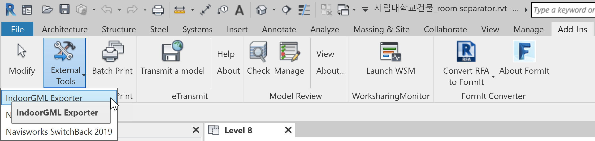

## Model review

Run IndoorGML Exporter to check the Validator's Rooms and Doors, check if there is a Not Place Room or a Door that is not connected to the Room as shown below, and if there is anything to be modified in the Model, proceed with modification.

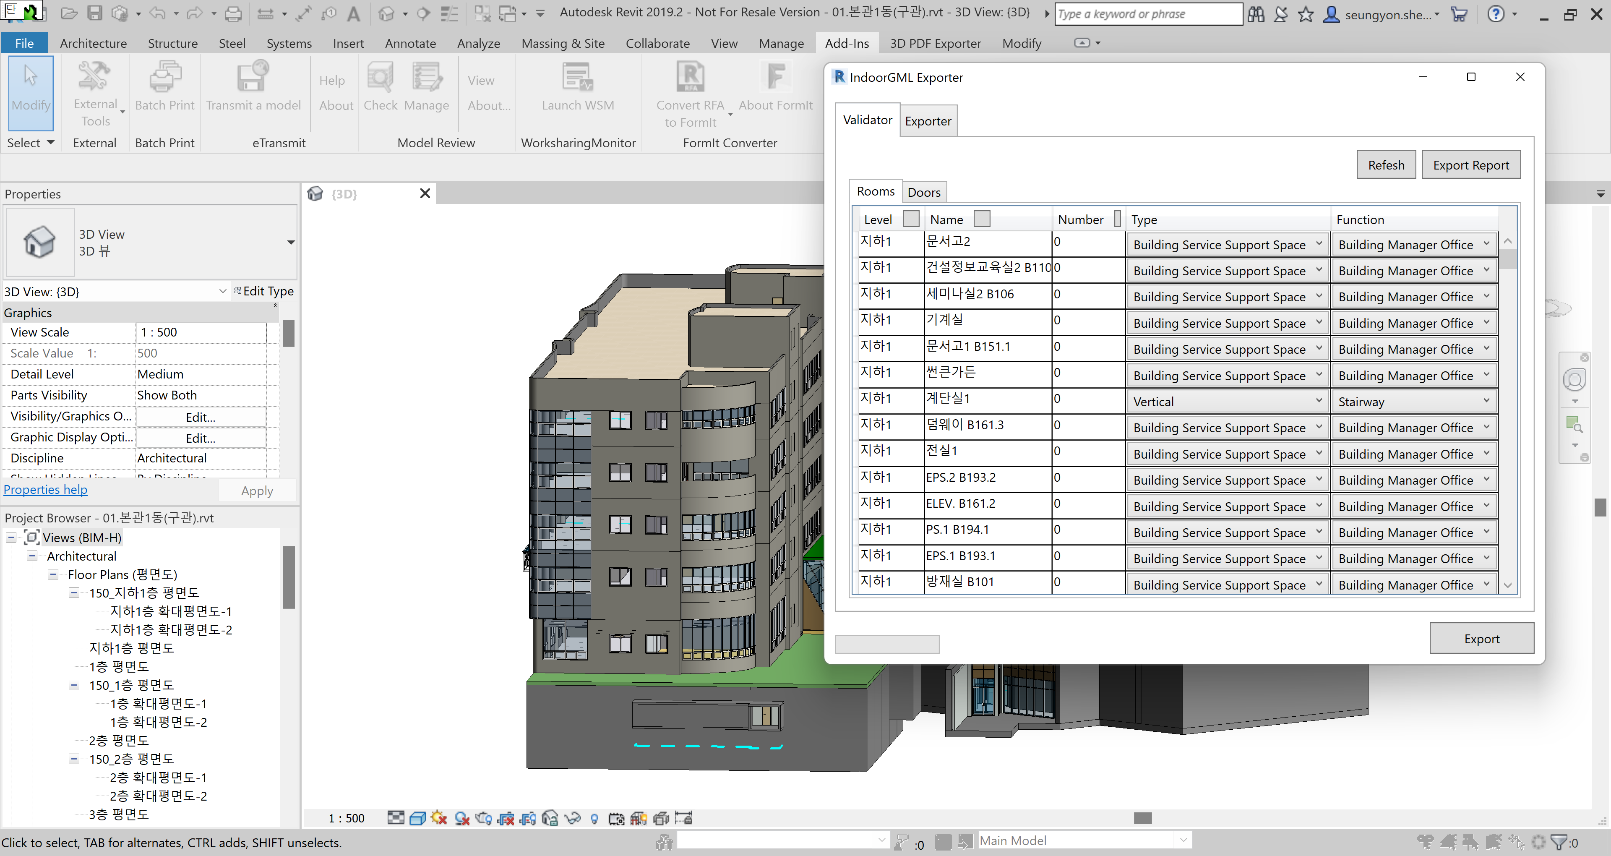

## Enter Room Class and Function

In the Rooms list table, you can enter the Class and Function of each Room. Apply class and function suitable for each room.

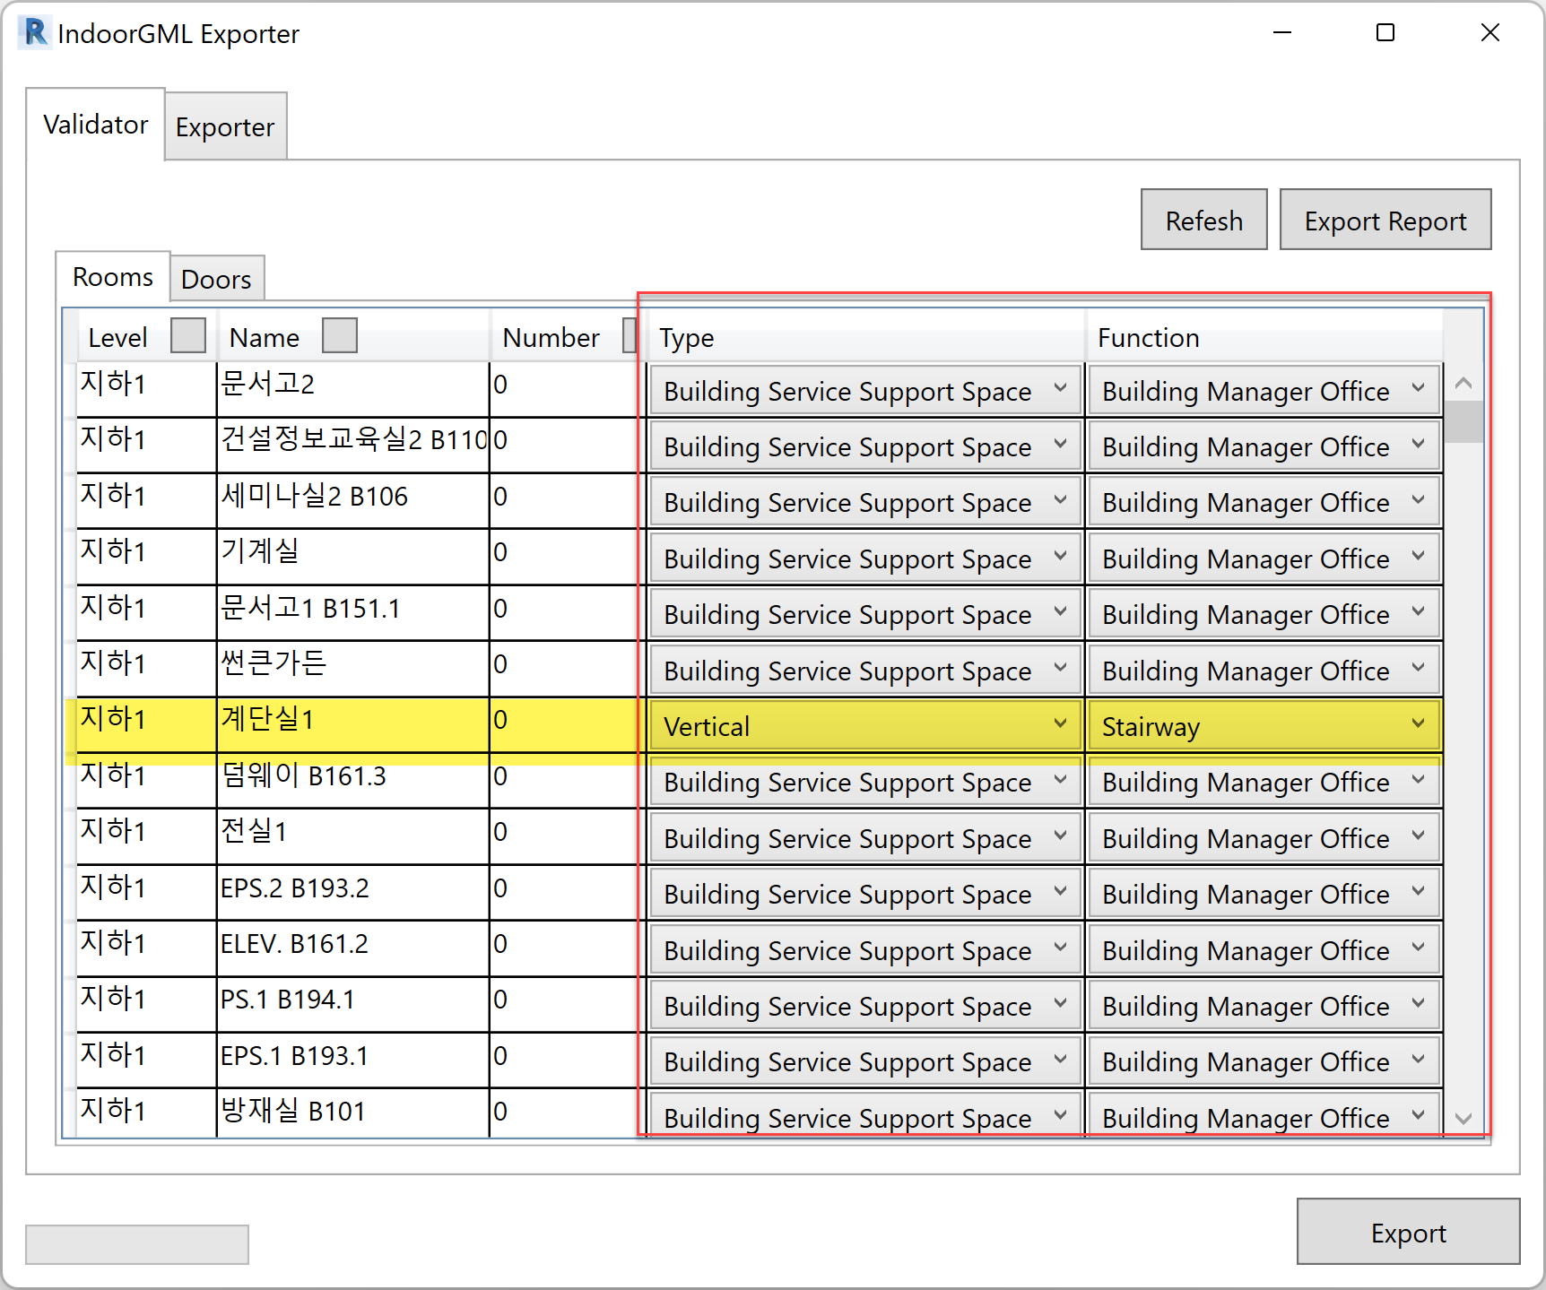

* In the case of Revit, the first values defined in Excel, Class: Building Service Support Space and Function: Building Manager Office, are entered and loaded as default values.
* In the case of Vertical Class, Vertical is automatically entered and loaded according to the Room name defined in the Exporter.

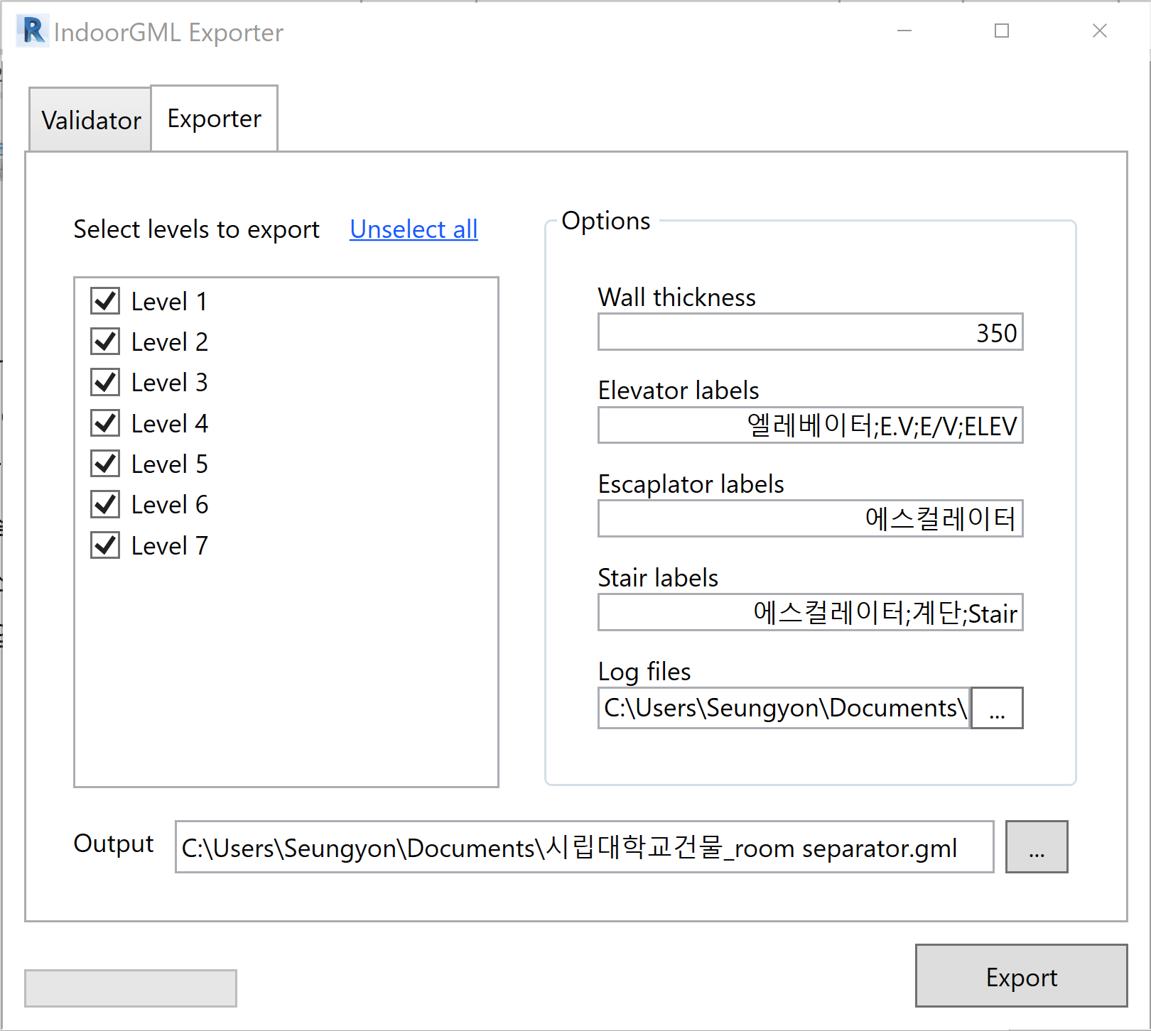

|  |
| --- |
| Class and Function values are based on the Excel table taken from the Class and Function list of Cell Space.  File Location: C:\Program Files\Autocad2IndoorGML\Config\unitSpaceClass and Function Code.xlsx  * Above excel refers to A.5. Code list of unitSpaceClass attribute and , A.6. code list of unitSpaceFunction property of 2021PG409-013 IndoorGML Data Model(Draft)_202100625.hwp  Please refer Understanding the Class and Function |

## Exporting

When the modification is completed in the above review, go to the Exporter tab and set the Exporter settings.

1. Level: Select the level to extract. Select Full Level to export the entire model.
2. Options:
   1. Enter the keyword of the room label to detect the room that will create a vertical path such as Elevator, Escalator, and Stair.
   2. These settings are also used to automatically apply the vertical path Class and Function.



1. Set the output file name and storage location, log file name, and storage location.
2. Click the Export button to extract IndoorGML.
3. You can check the result immediately while IndoorGML Editor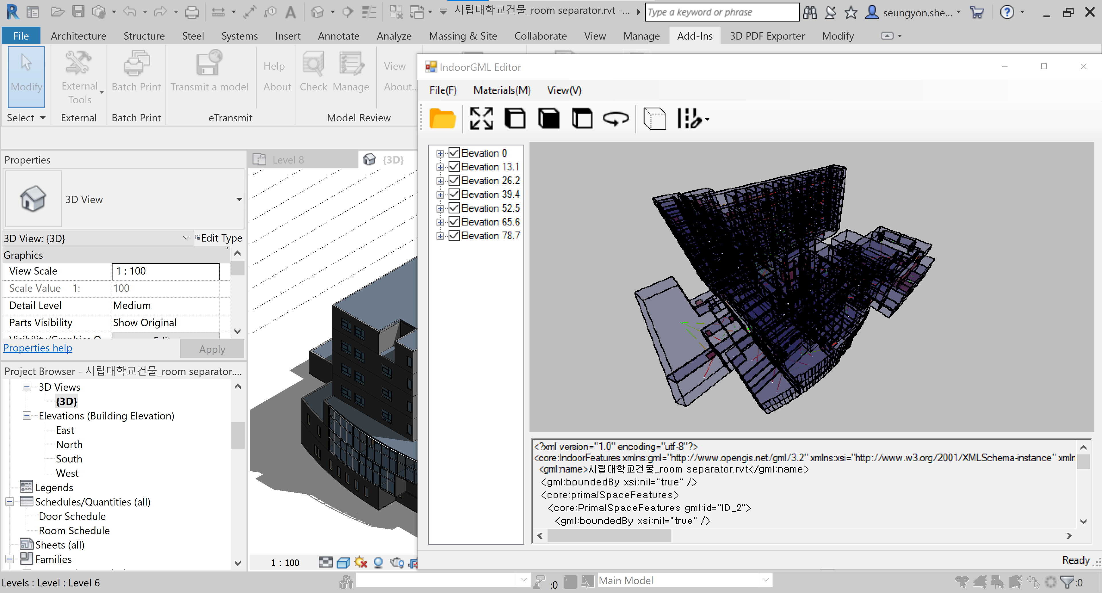

# 3.IndoorGML Editor

## IndoorGML File Review

As shown in the figure below, the room name is displayed in the General Space list, and if you select the room name, you can highlight the room to check whether the transition is properly connected.

In addition, Boundary, Cell Space Boundary, and State information are displayed.

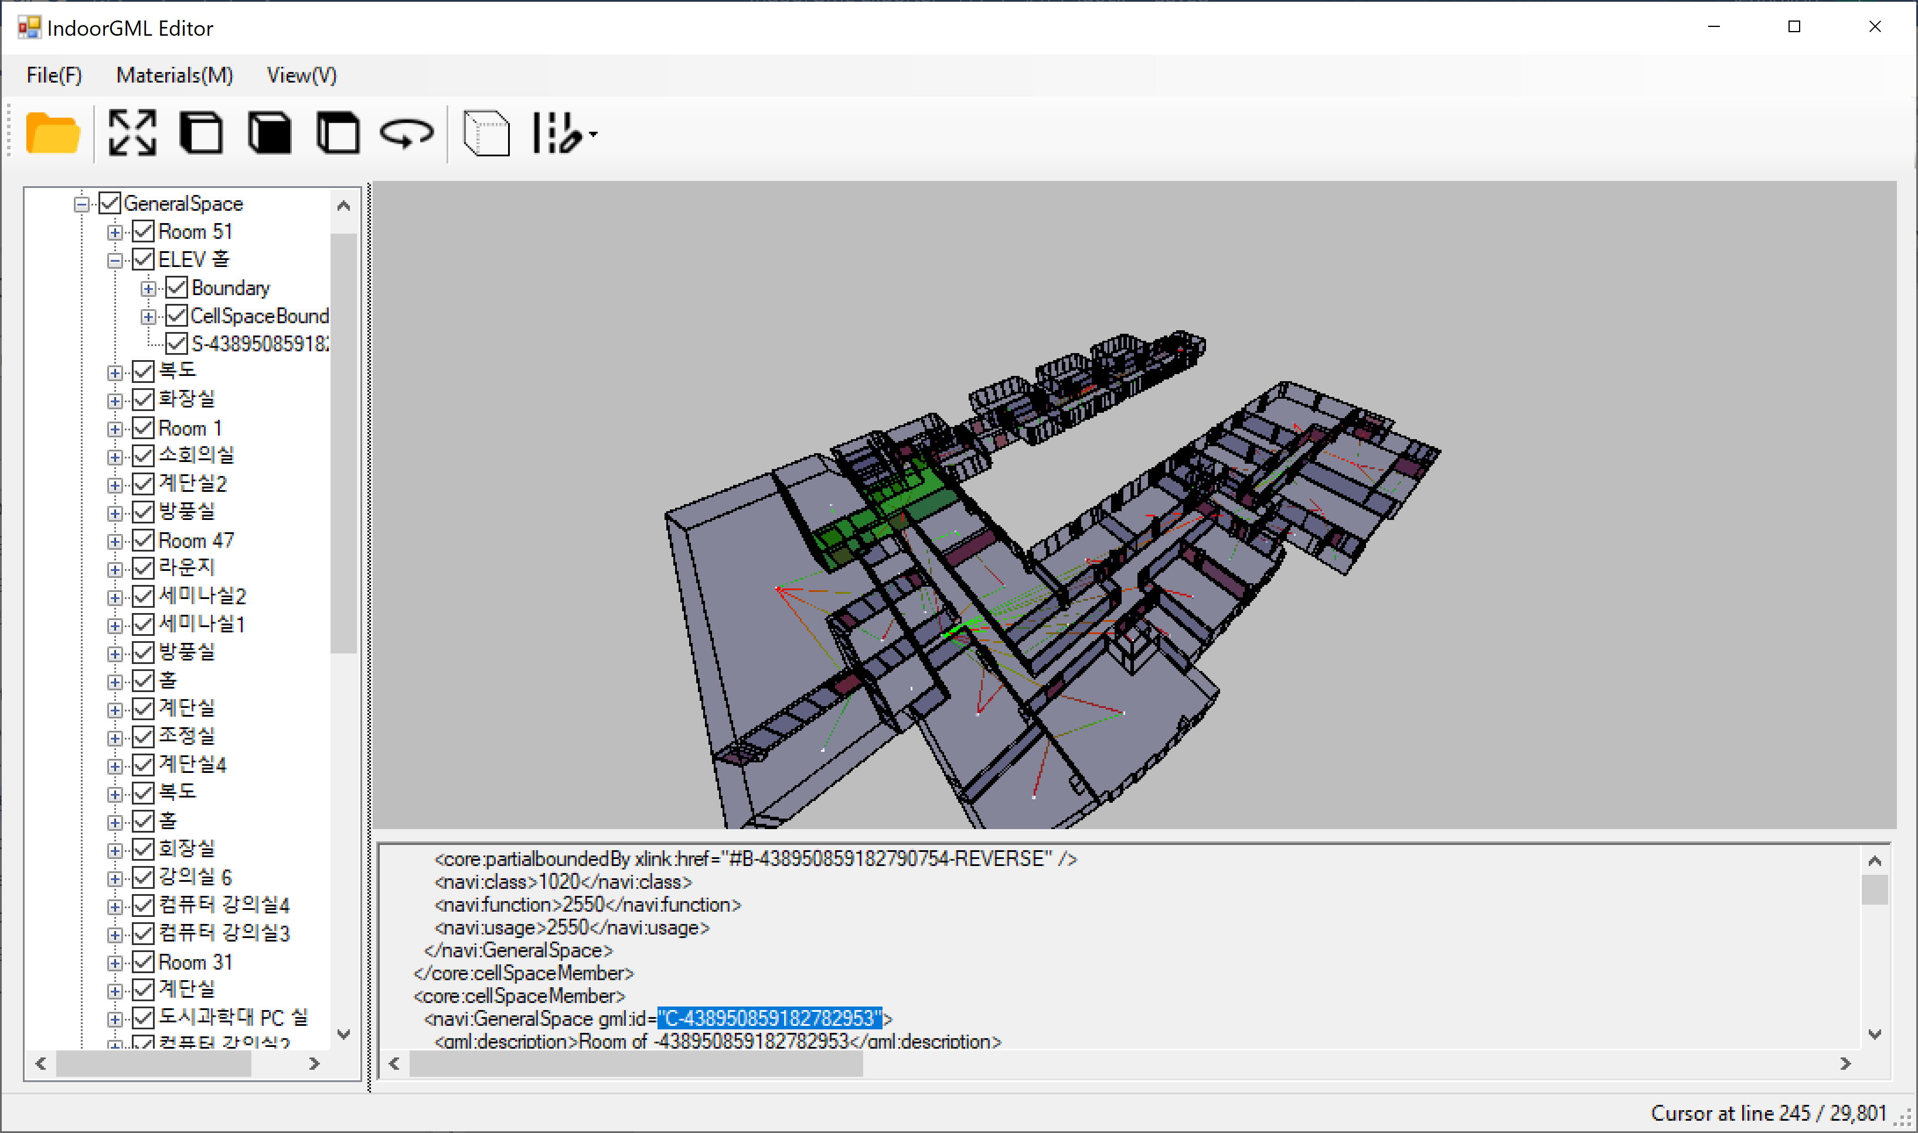

## Edit

IndoorGML extracted from AutoCAD Plug-in can be edited by following three functions in IndoorGML Editor.

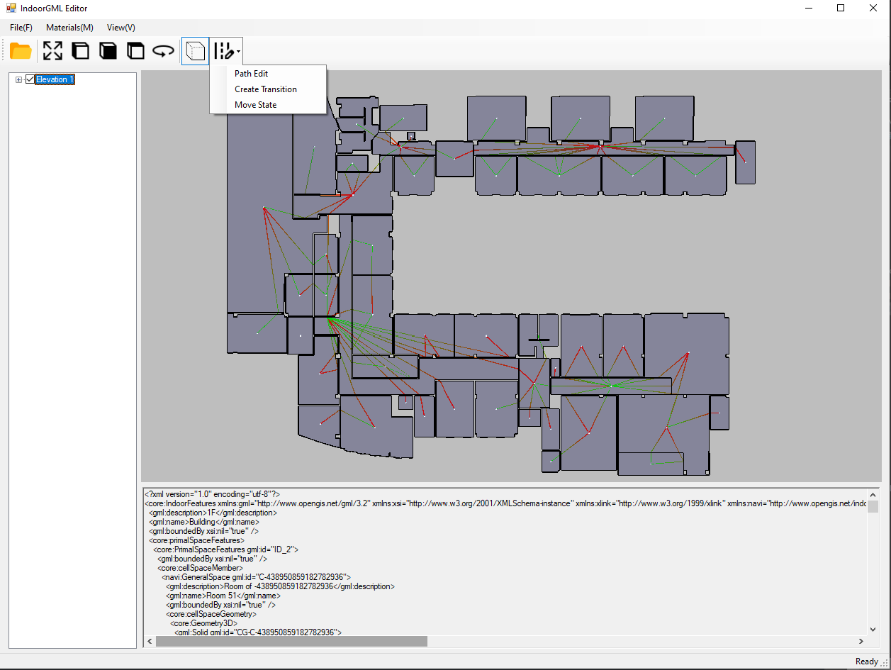

|  |  |  |
| --- | --- | --- |
| Menu | Description | Remarks |
| Path Edit | Edit the path of the edge (Transition) |  |
| Create Transition | When there is no transition between rooms, this function is used to create an edge |  |
| Move State | Modify the location of the node (State) |  |

### Move State Function

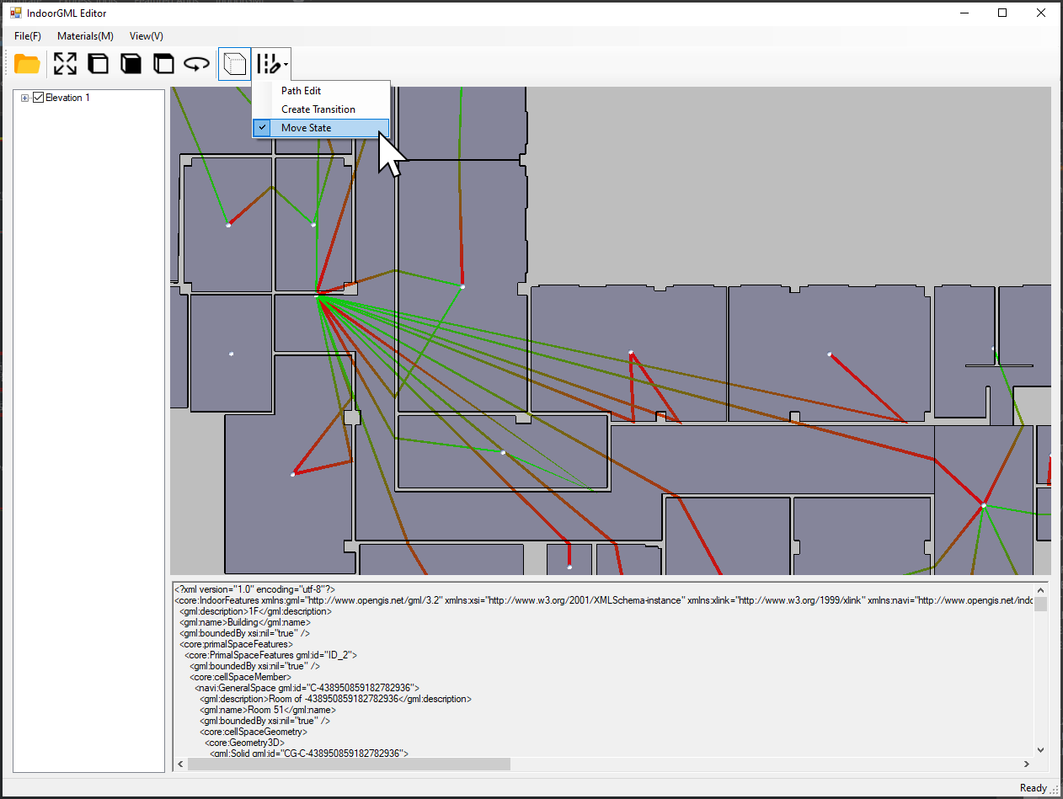

|  |  |  |
| --- | --- | --- |
| Step | How it works | State |
| 1 | Hold Ctrl key and click State with the mouse button | The color of the State is highlighted in blue as shown in the screen below. |
| 2 | Hold down the Ctrl key and drag and drop the State to the desired location with the mouse. | The state is highlighted in blue, and when you move the state, the connected transitions do not follow. |
| 3 | Press Esc to end editing. | If you press Esc, the highlight of the state is turned off, and the connected transition is reconnected according to the moved state position. (Picture below) |

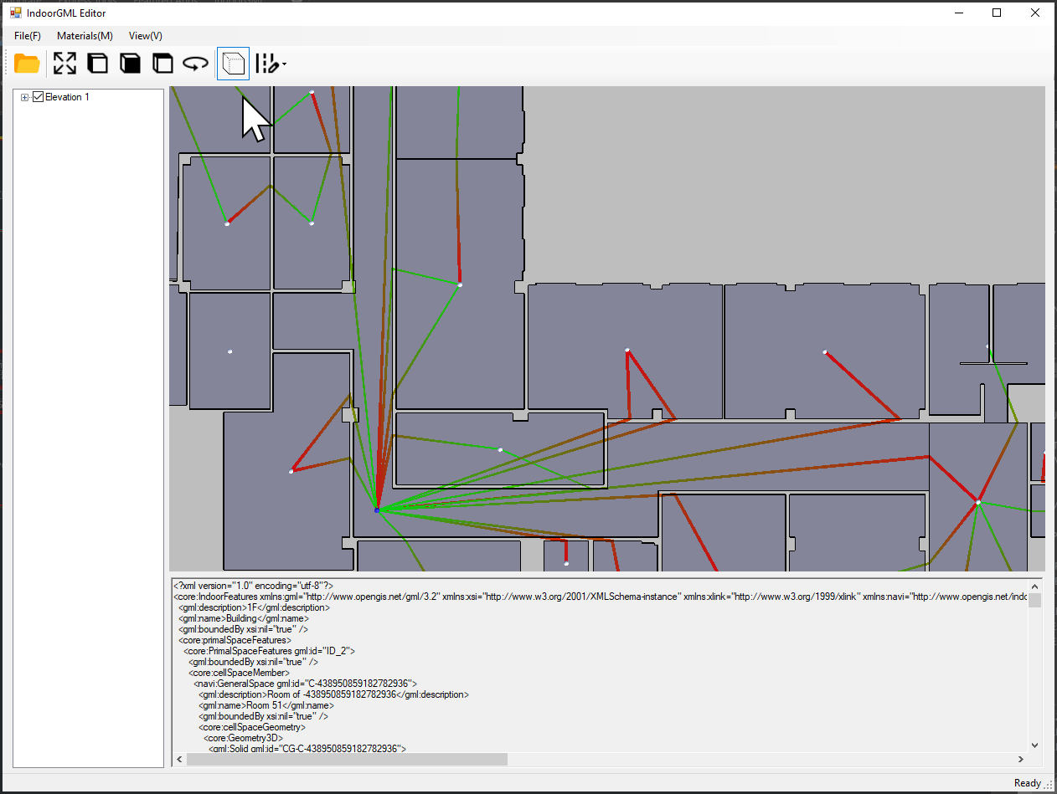

### Path Edit

Select Path Edit from the menu.

1. Hold down the Ctrl key and select the transition.

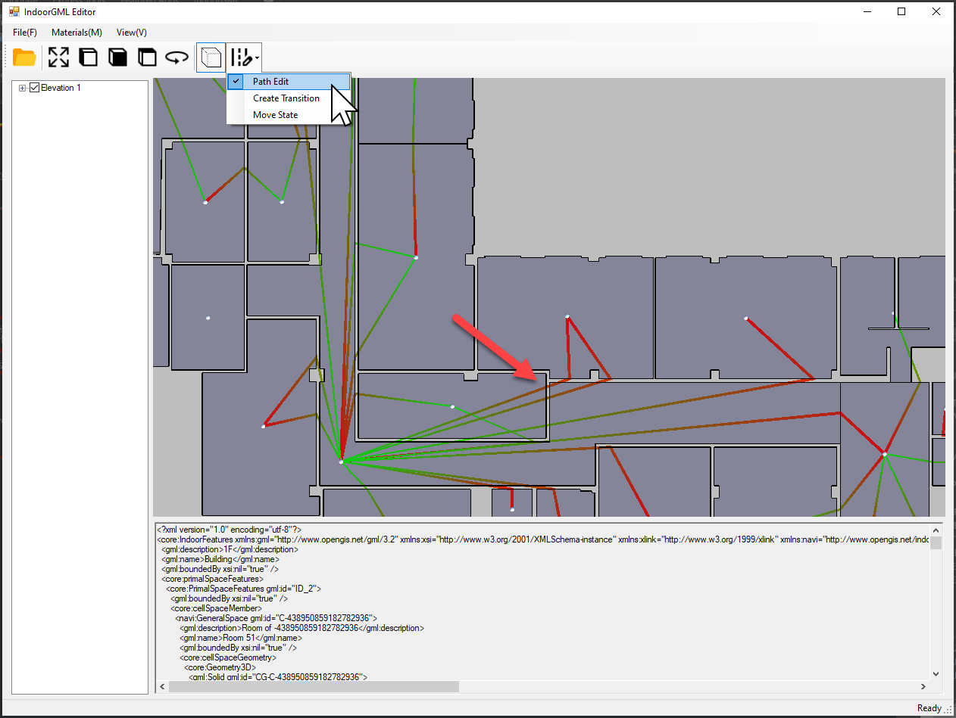

1. The selected Transition is highlighted, as shown below, and the other Transitions disappear. While holding down the Ctrl key, click the point you want to give the path vertex (red dot in above picture) and move it to the desired location point(like red arrow) with using the mouse drag and drop.

|  |  |
| --- | --- |
|  |  |

1. Press Esc to clear the highlight, and other transitions that have been hidden are displayed.

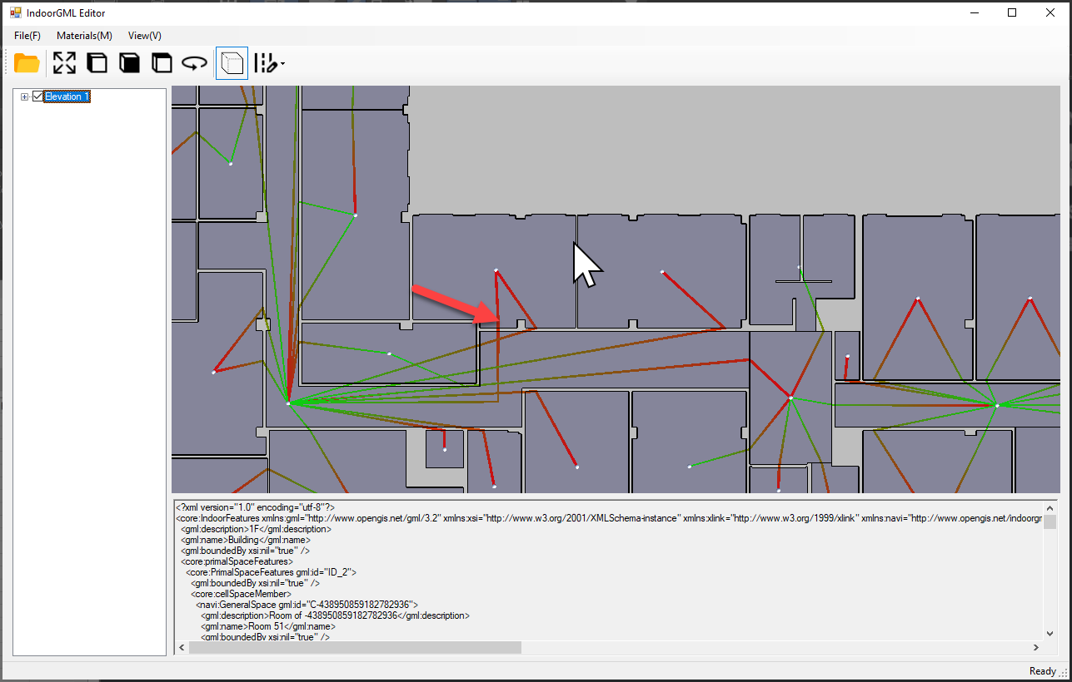

Create Transition

If the transition has not been created from AutoCAD Plug-in, you can create a transition as follows.

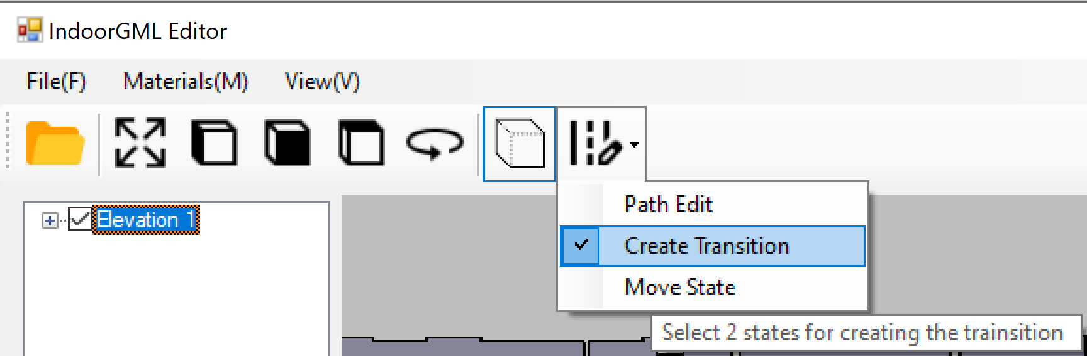

Hold down the Ctrl key and select the unconnected state. When State is highlighted in blue, you enter edit mode.

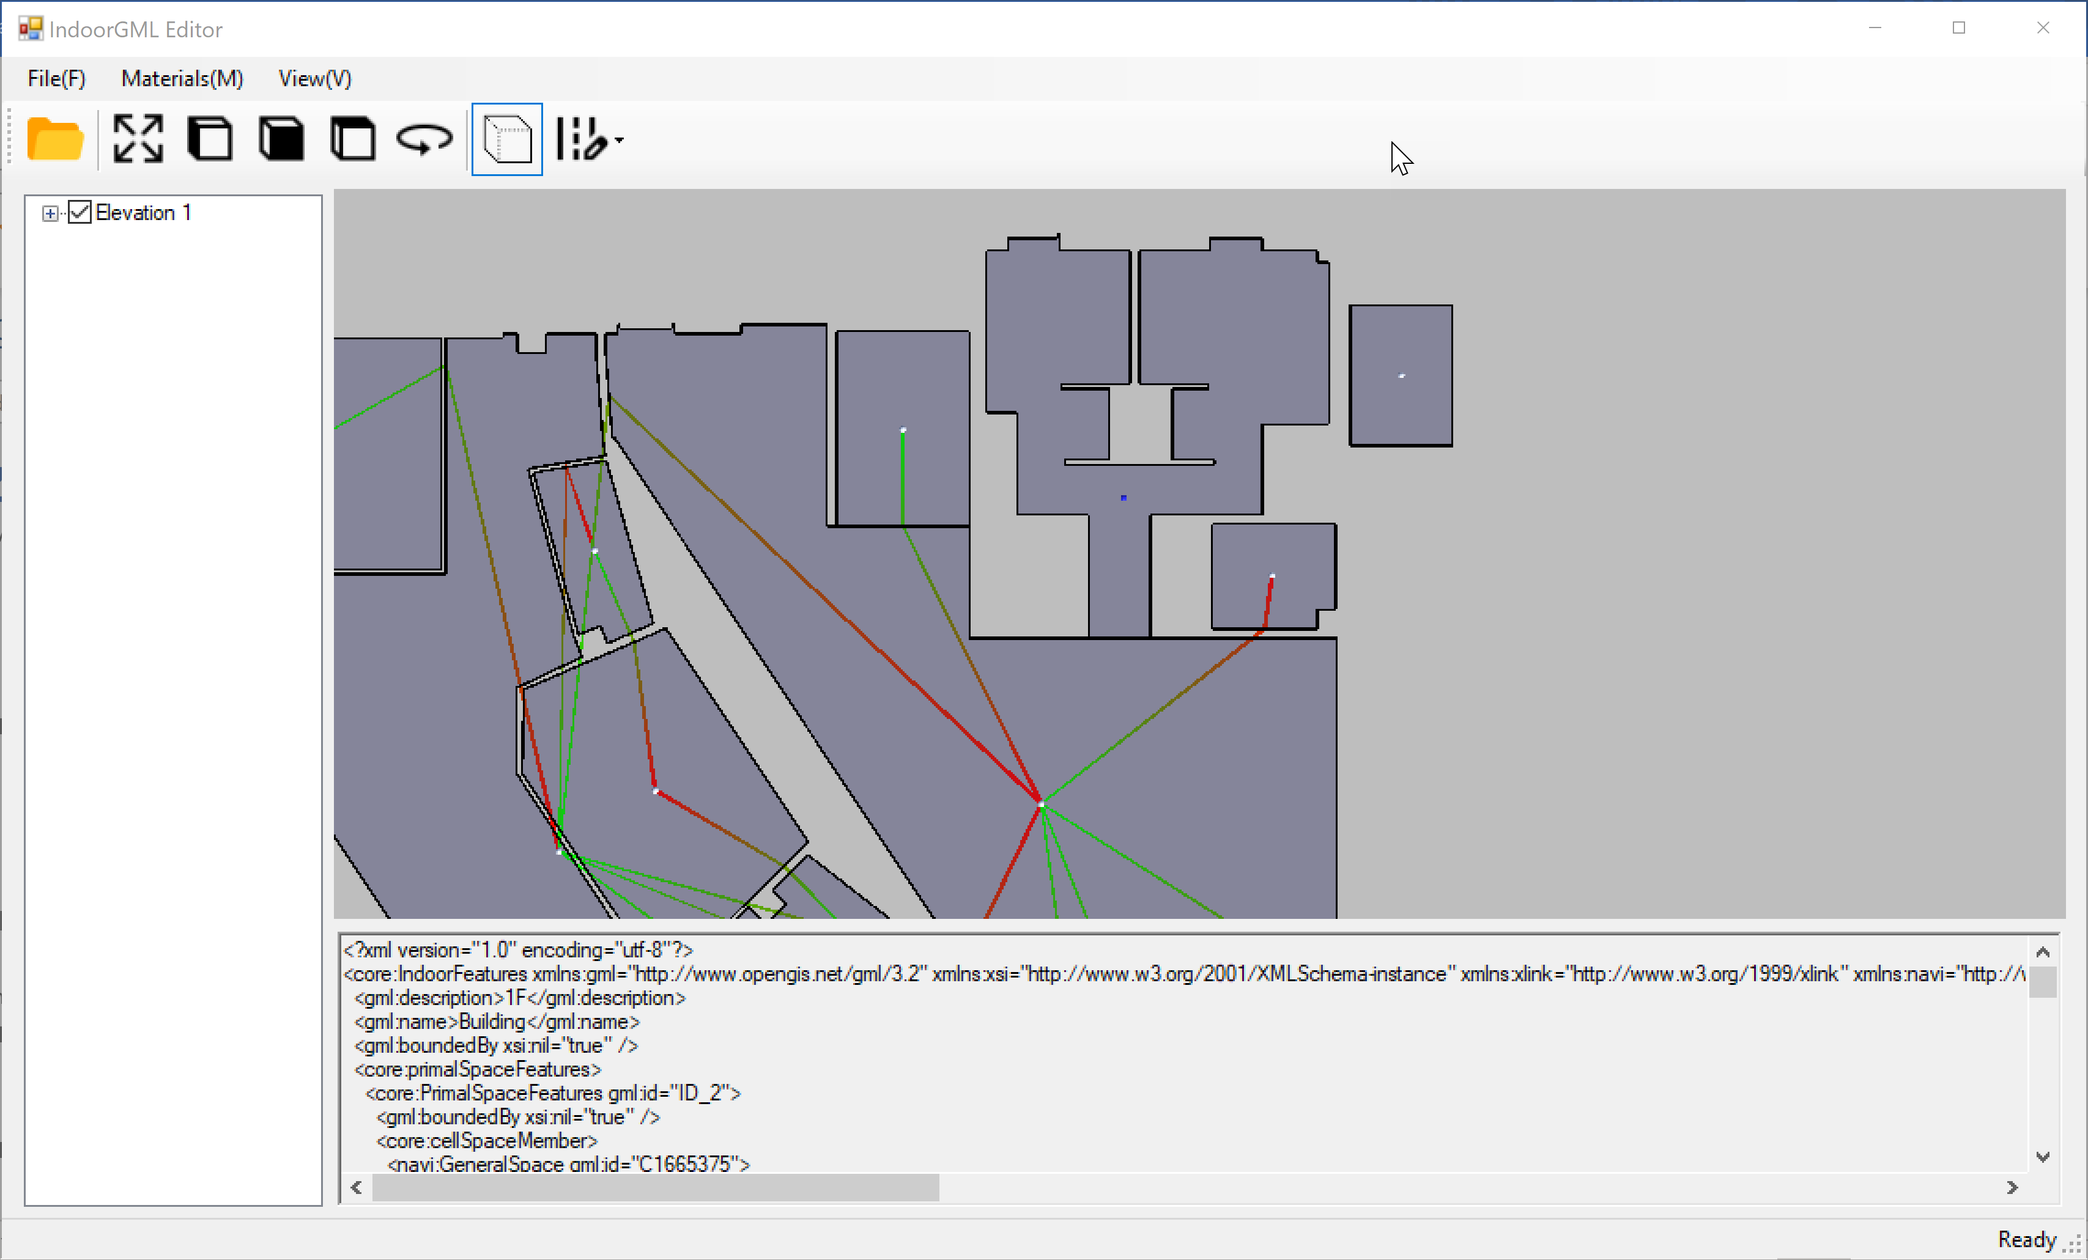

Hold down the Ctrl key and select the state to be connected and press Esc to create a transition that connects the two states.

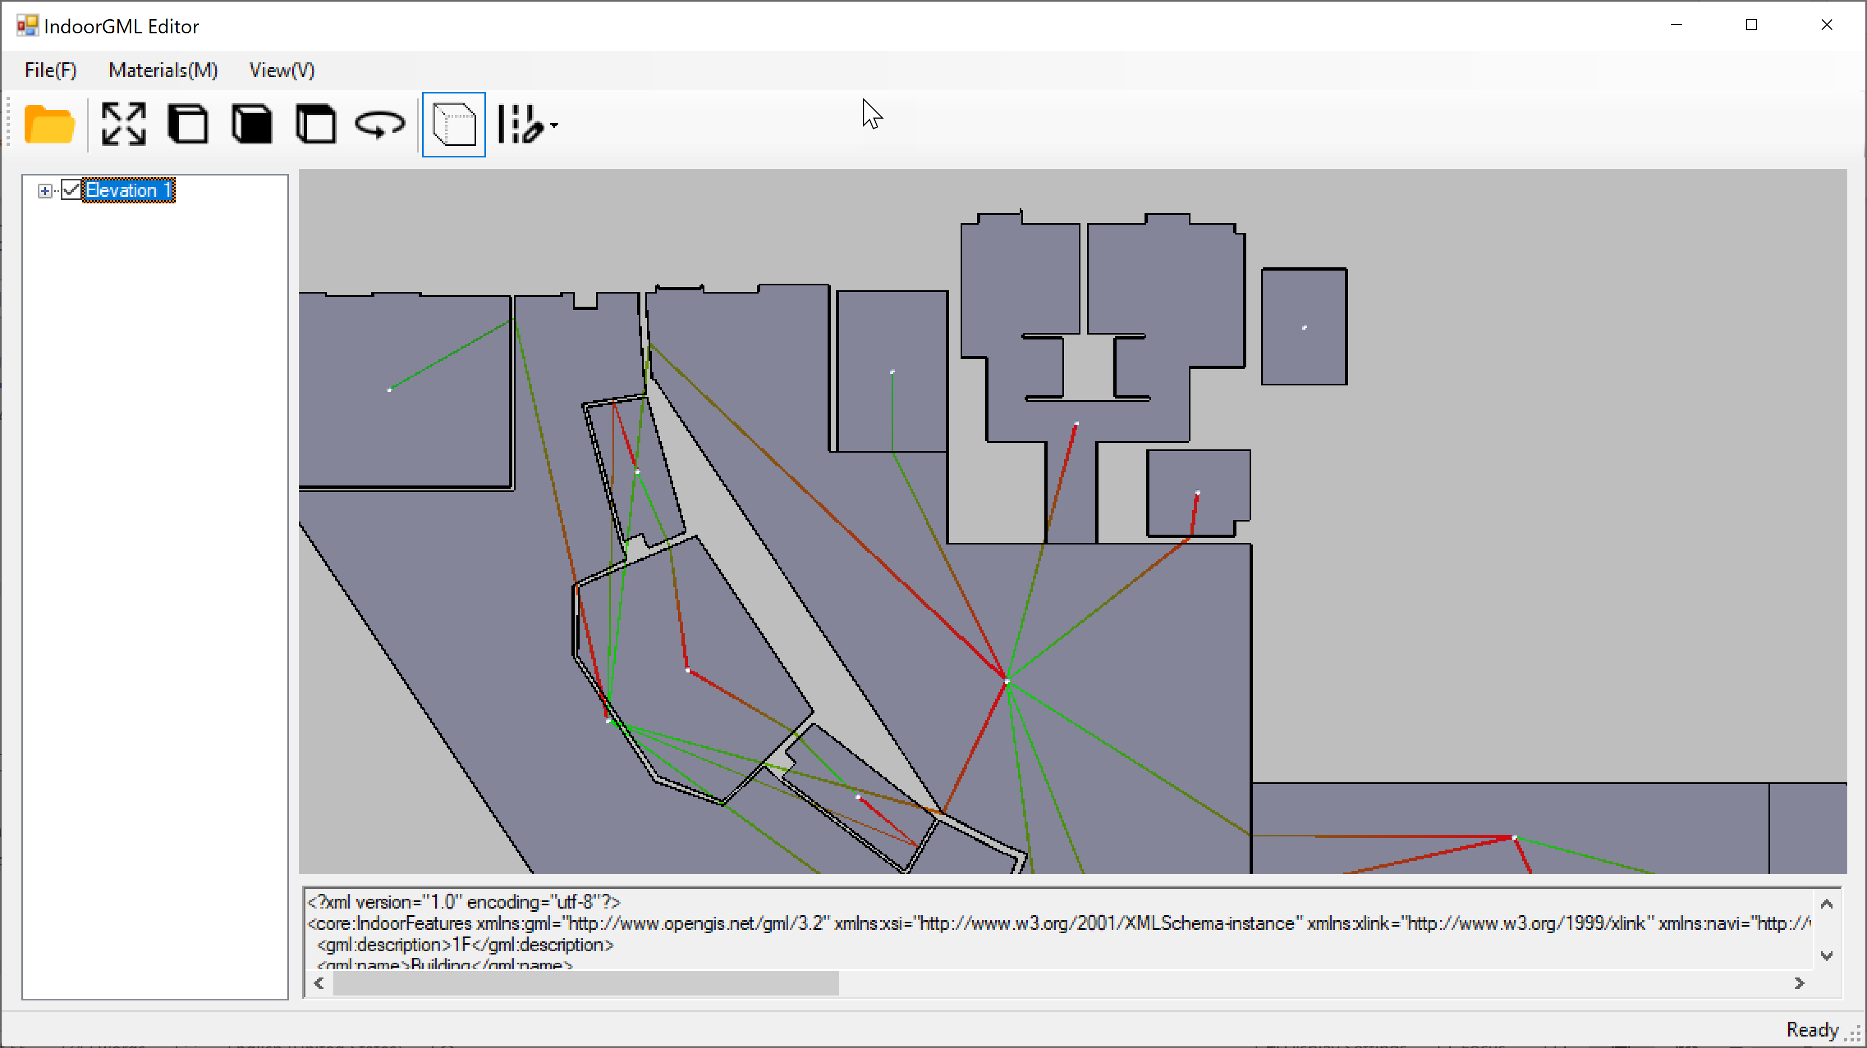

## Cell Space Data Table – Building energy information visualization Example

### Data Table Setting > Cell Space

Set up building energy information for Cell Space and perform settings for visualization.

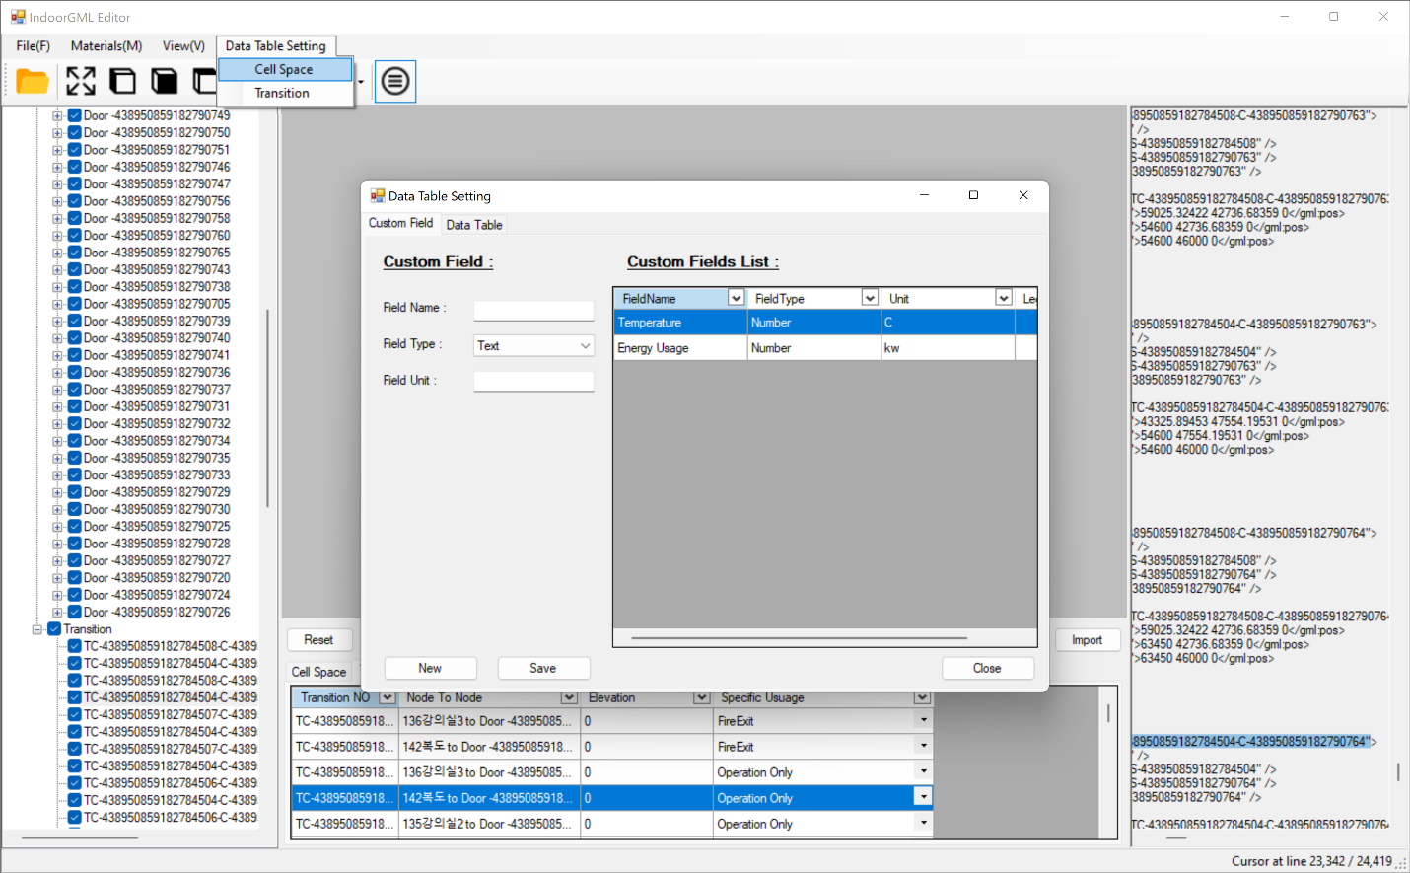

#### Customer Field

Create/modify building energy information fields and choose whether or not to show Legend.

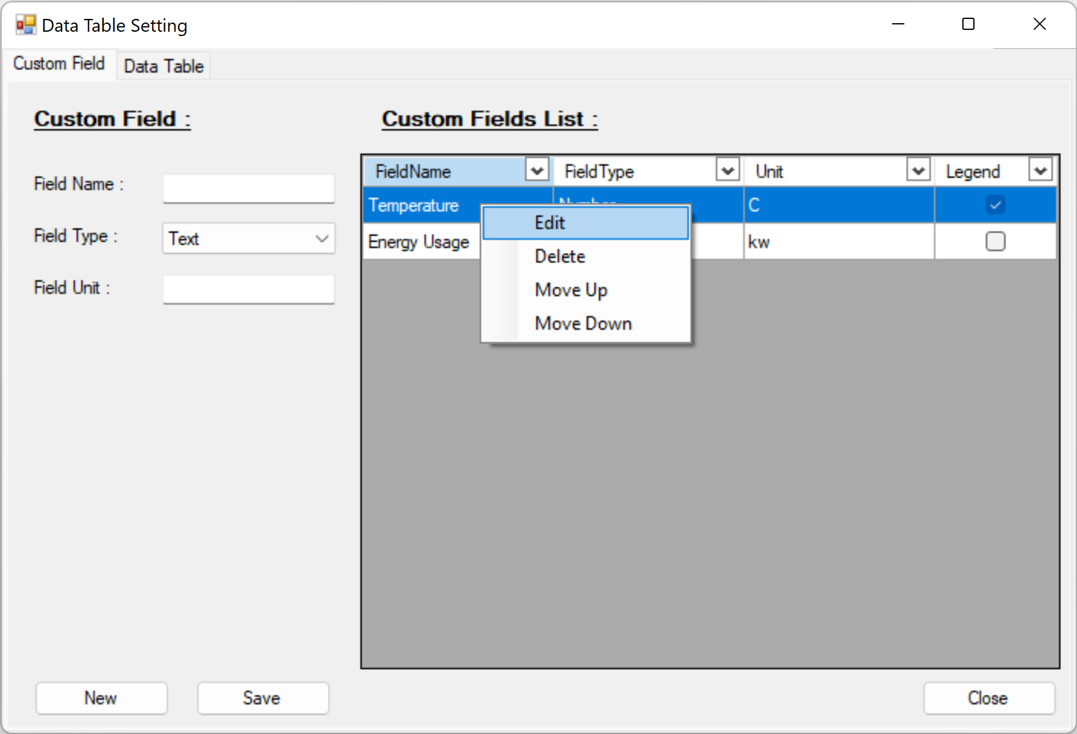

#### Data Table

In the Data Table, set whether to display the field on the main app window and set the Legend color.

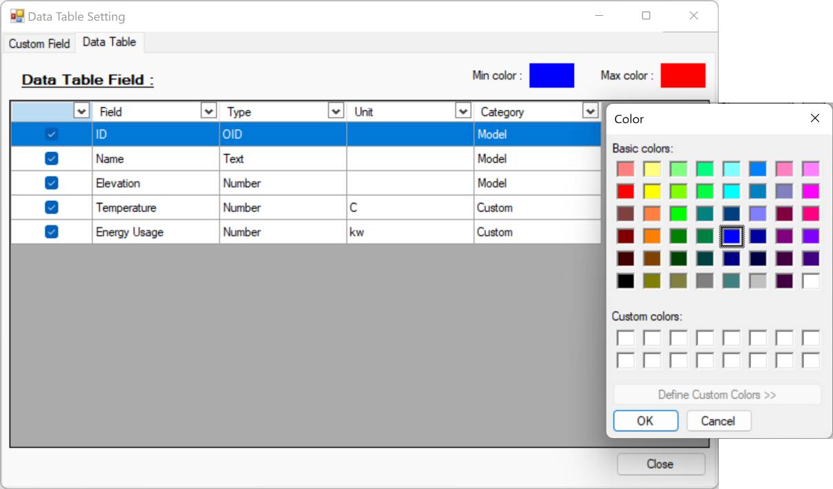

### Cell Space Data Table in the main app window

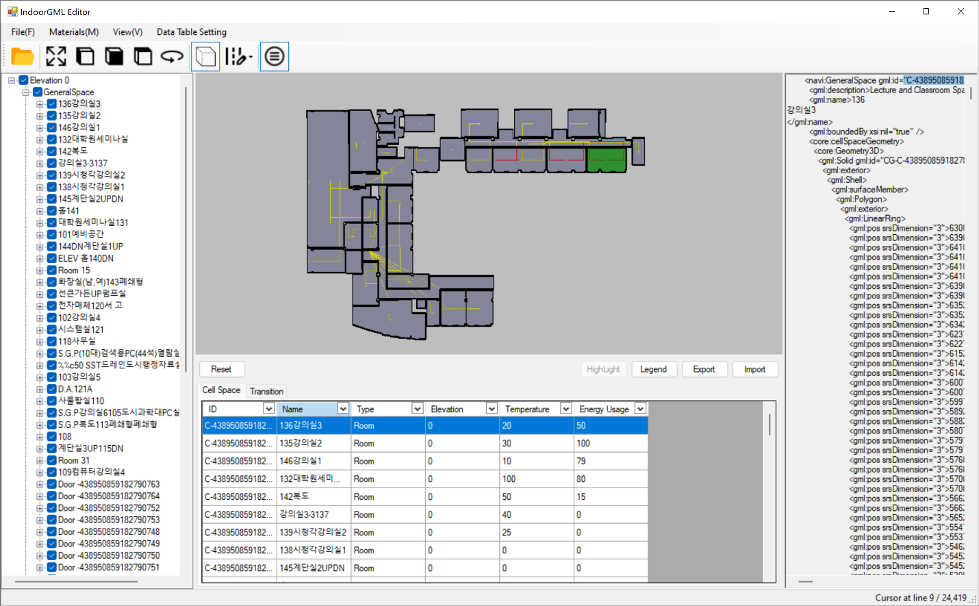

#### Filter Apply for the Data Table

You can browse data by setting a filter for all fields.

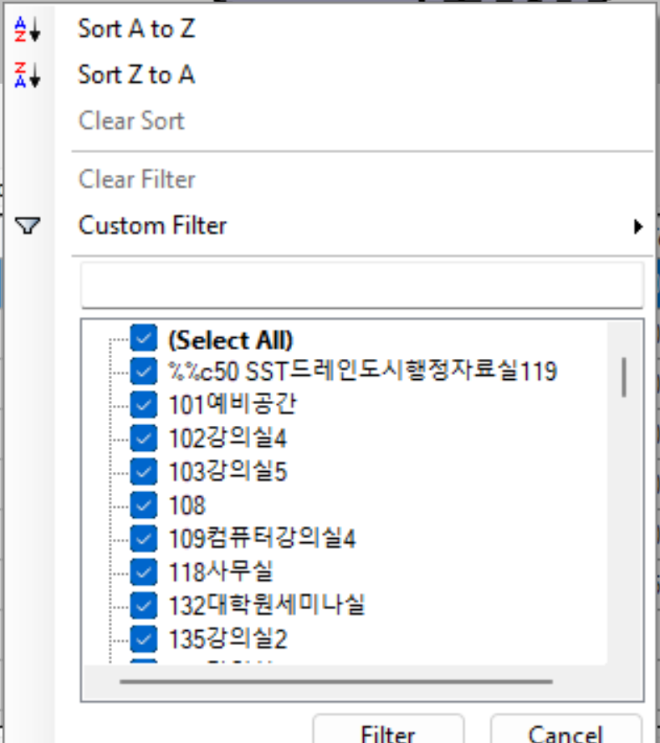

#### Legend Apply

For Field with Legend On, a menu is created as shown below and can be visualized.

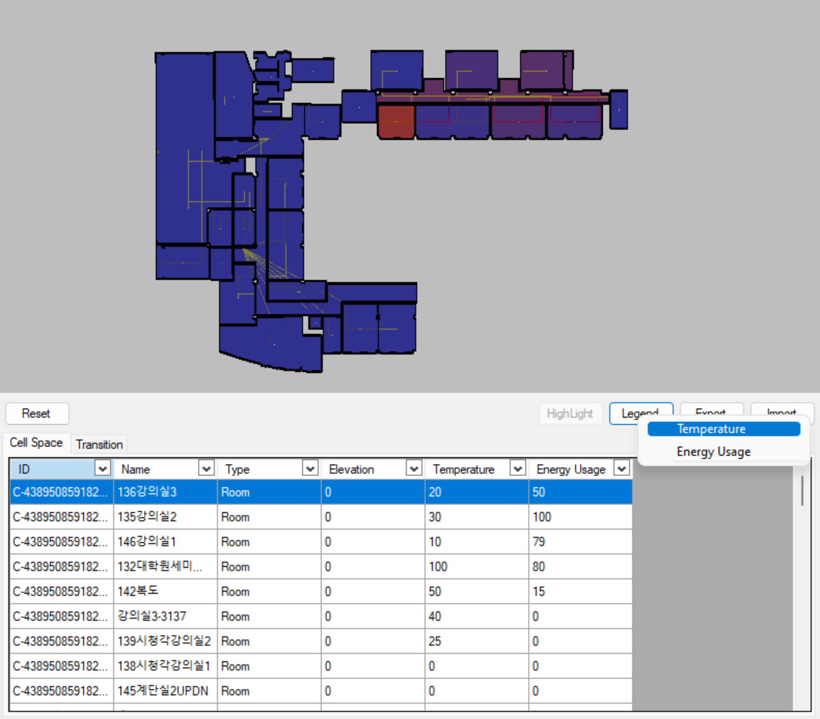

#### Excel Export

Building energy information values manually entered in the IndoorGML Editor’s Data Table can be exported to an Excel file, modified, and then re-imported.

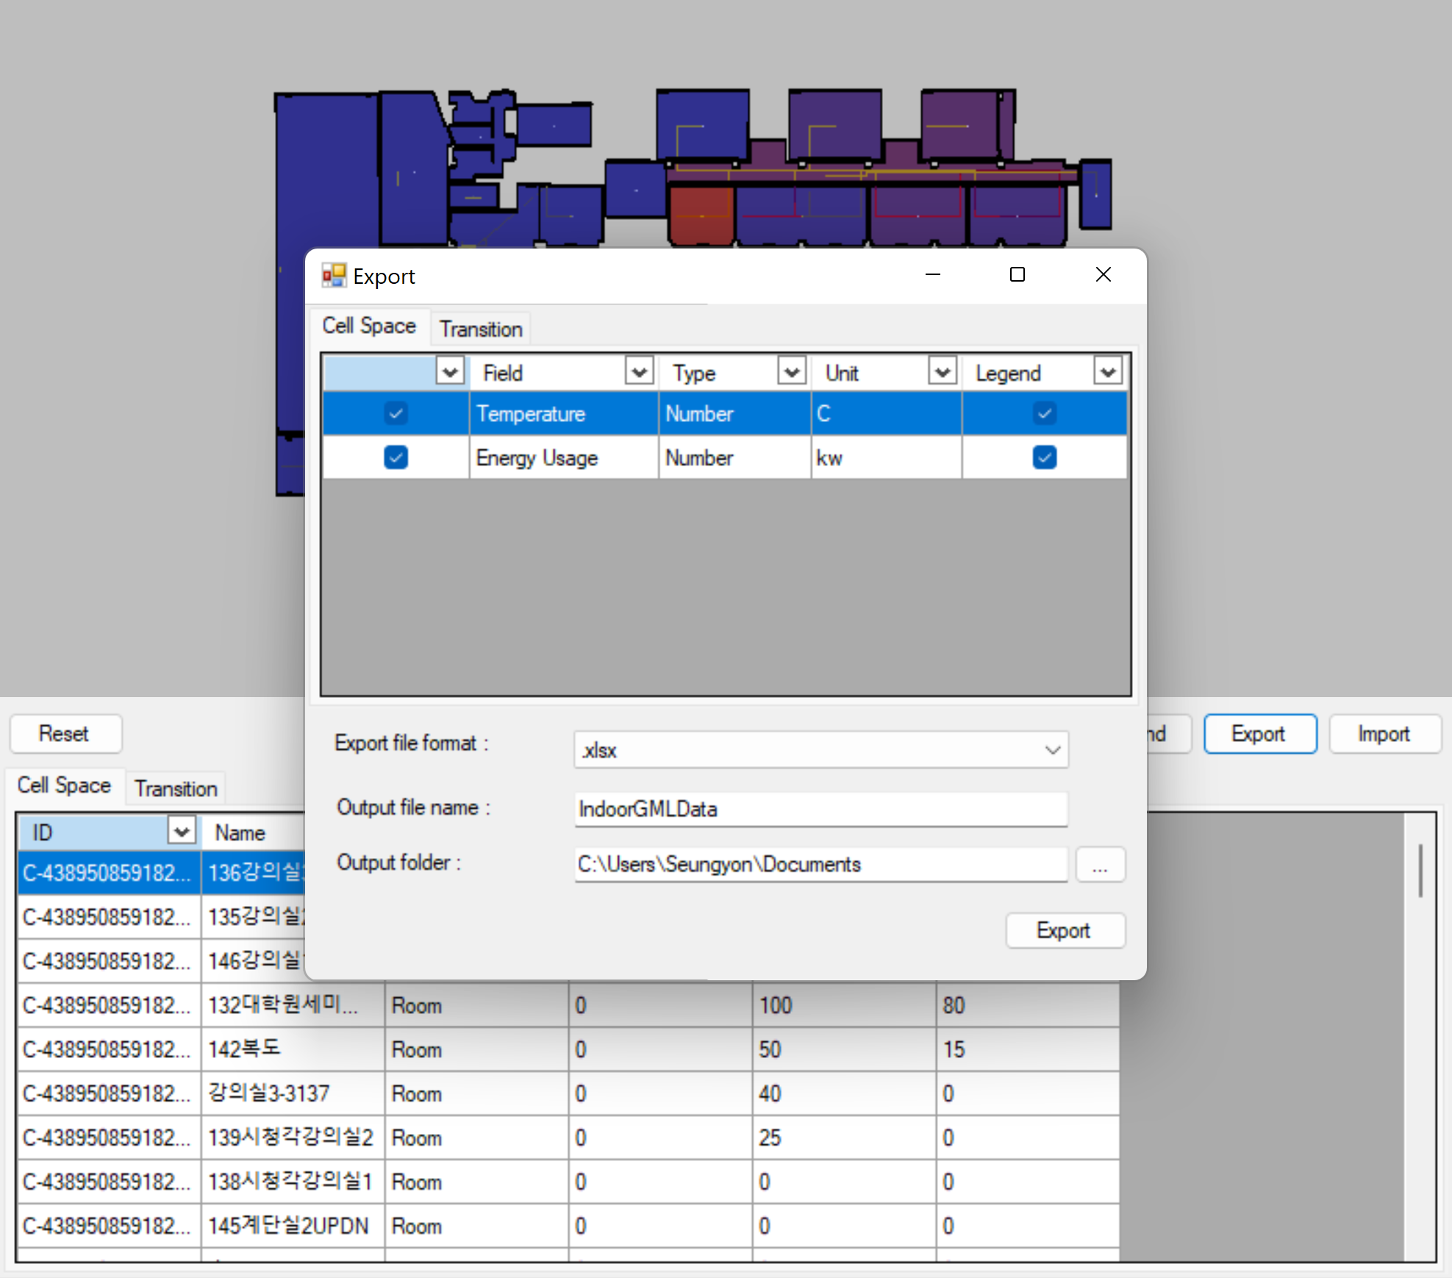

After modifying/entering the energy information value in the extracted Excel file, import it. Be careful not to modify the field name and ID values. (Please do not edit values in red)

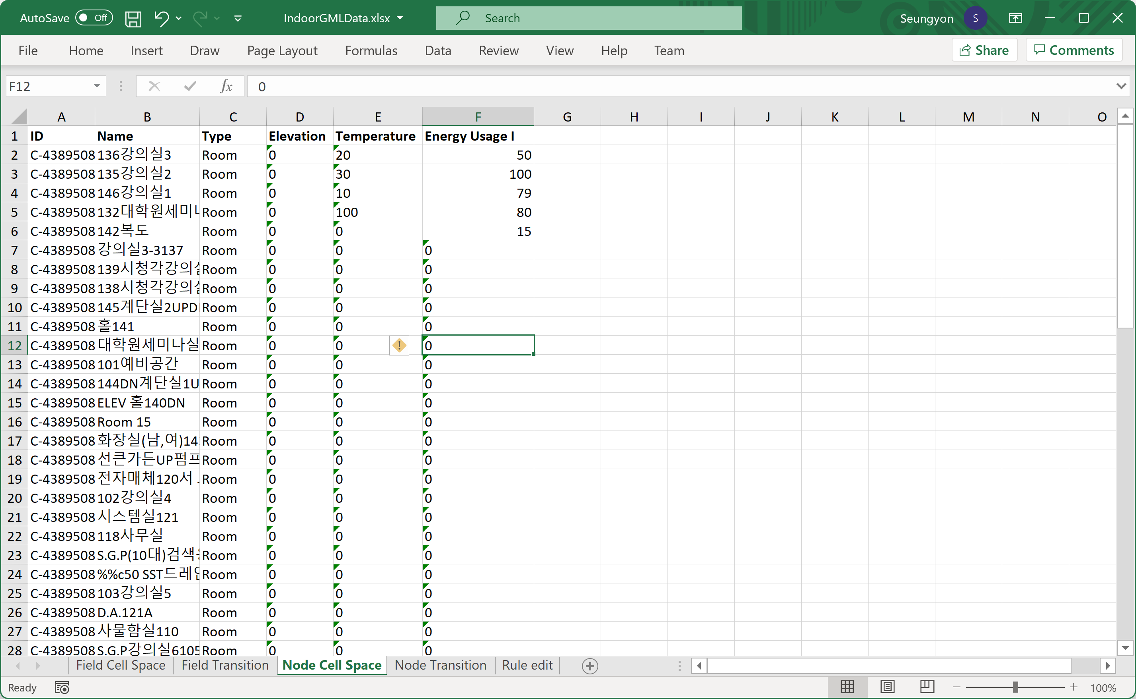

## Transition Data Table

### Data Table Setting > Transition

Enter additional information in Transition and perform settings for visualization.



#### Custom Field

Enter the Custom Field information to be added to the Transition.

Enter information in Transition as a List and list the information to be entered in the Field list.

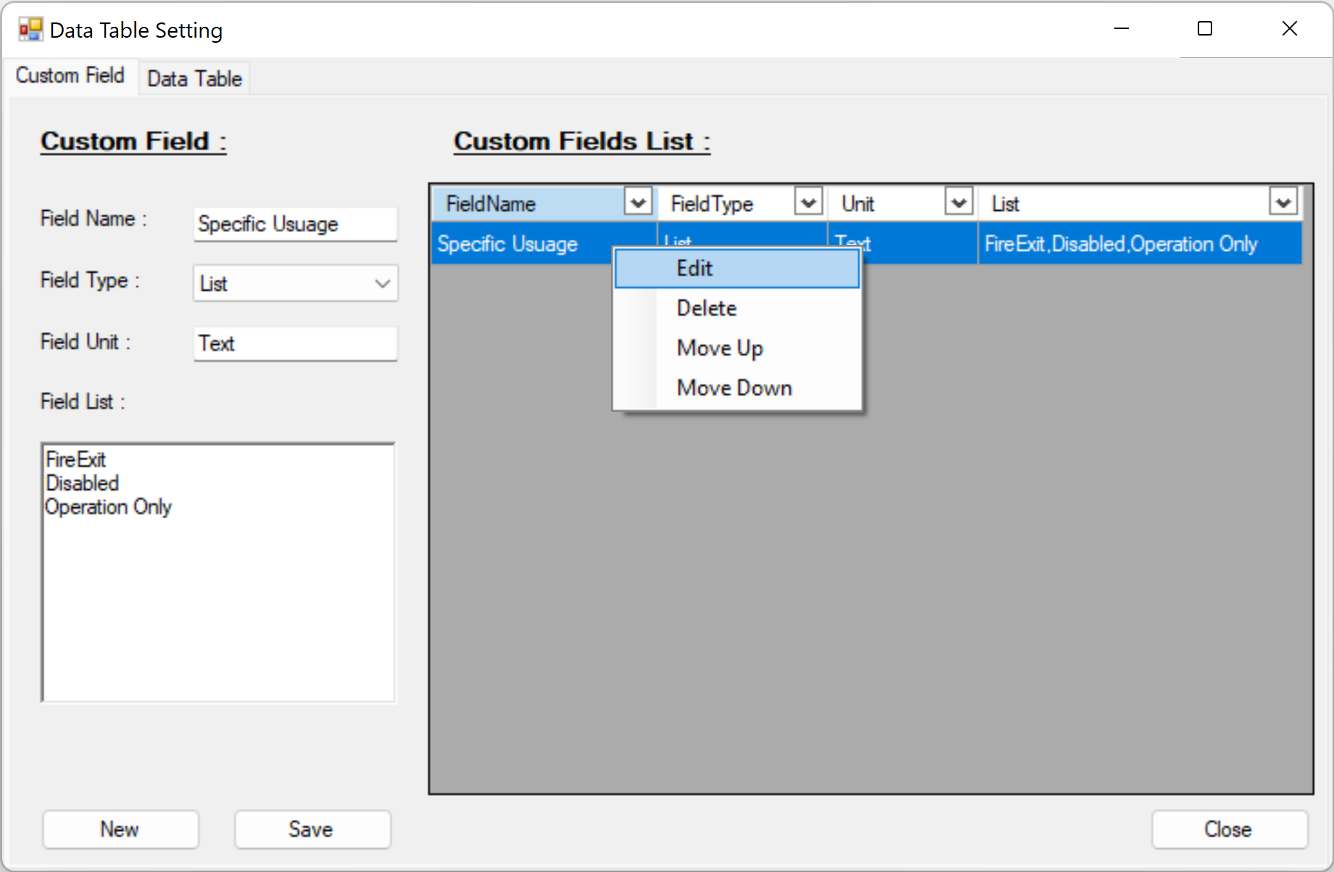

#### Data Table

Set the information to be displayed in the Transition Data Table of the main app window.

The field in which Category is displayed as Model is a field from IndoorGML Model and cannot be modified, and can only be displayed or not in Data Table.

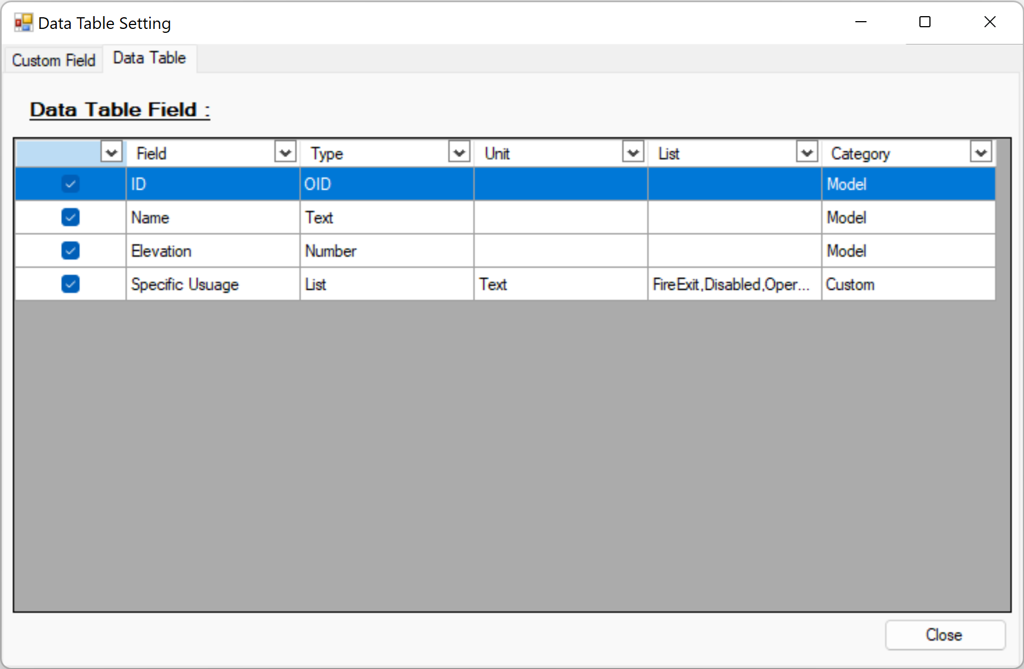

### Transition Data Table in Main window

#### Data Edit

The data registered in the Custom Field is displayed as a list as shown on the screen, and you can select a different value and edit it.

The default is the first value.

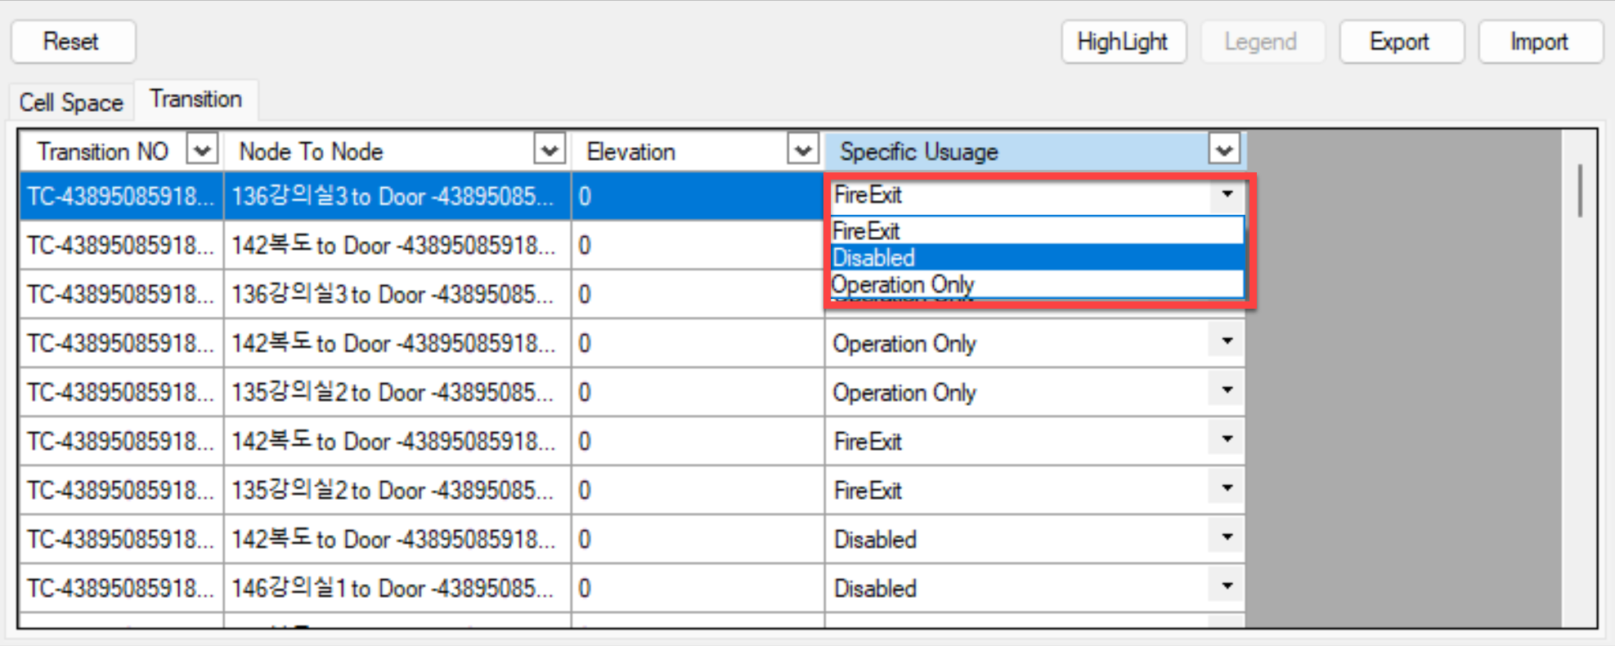

The default value is the first value set in the Customer Field. In our example, it is “Fire Exit”.



#### Transition Highlight

First, apply Filter and then press the Highlight button, the transition will be Highlighted in yellow as shown below.

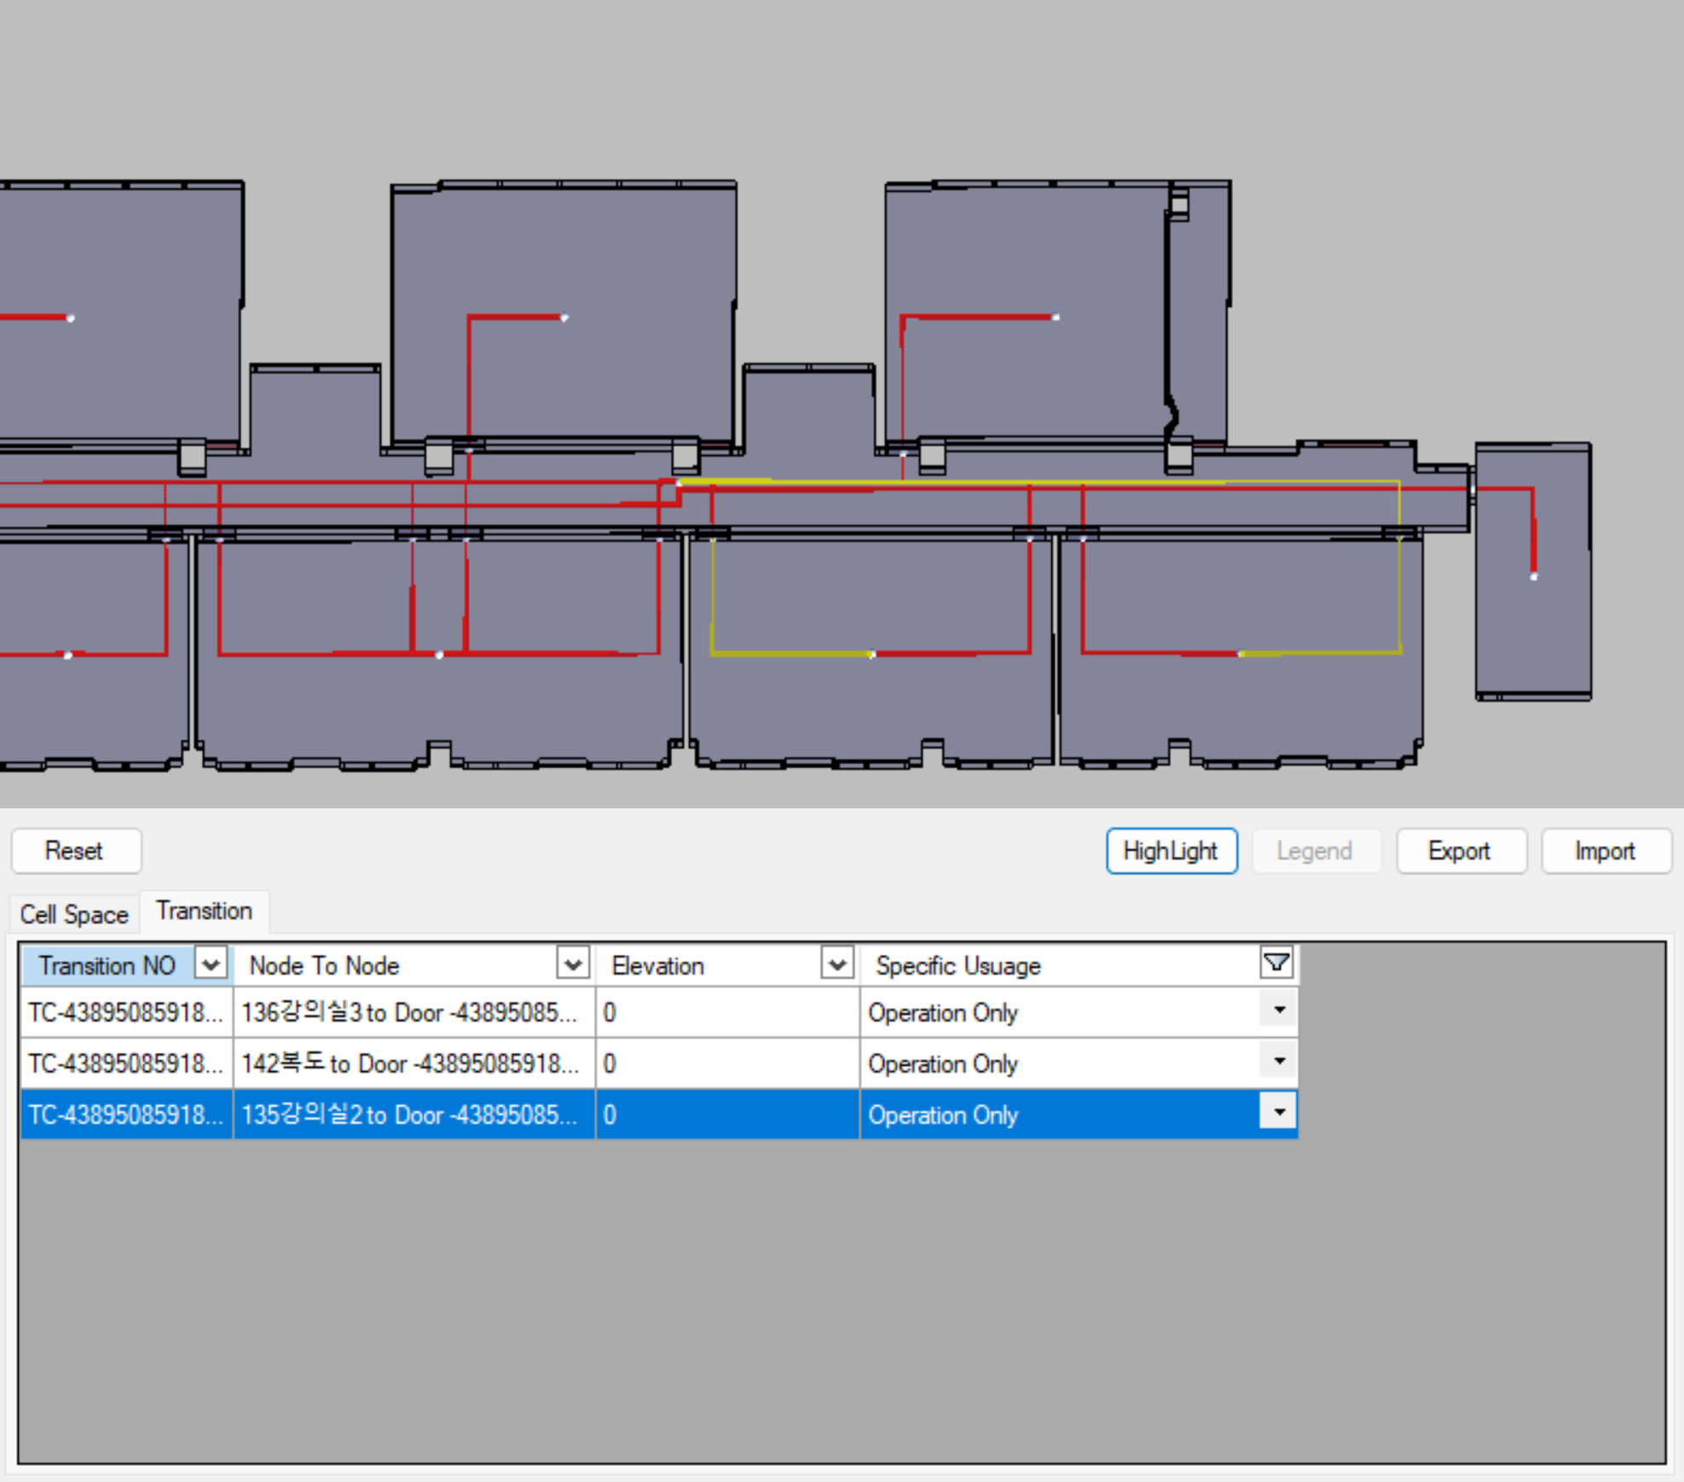

[Note] The currently selected transition is displayed in blue.

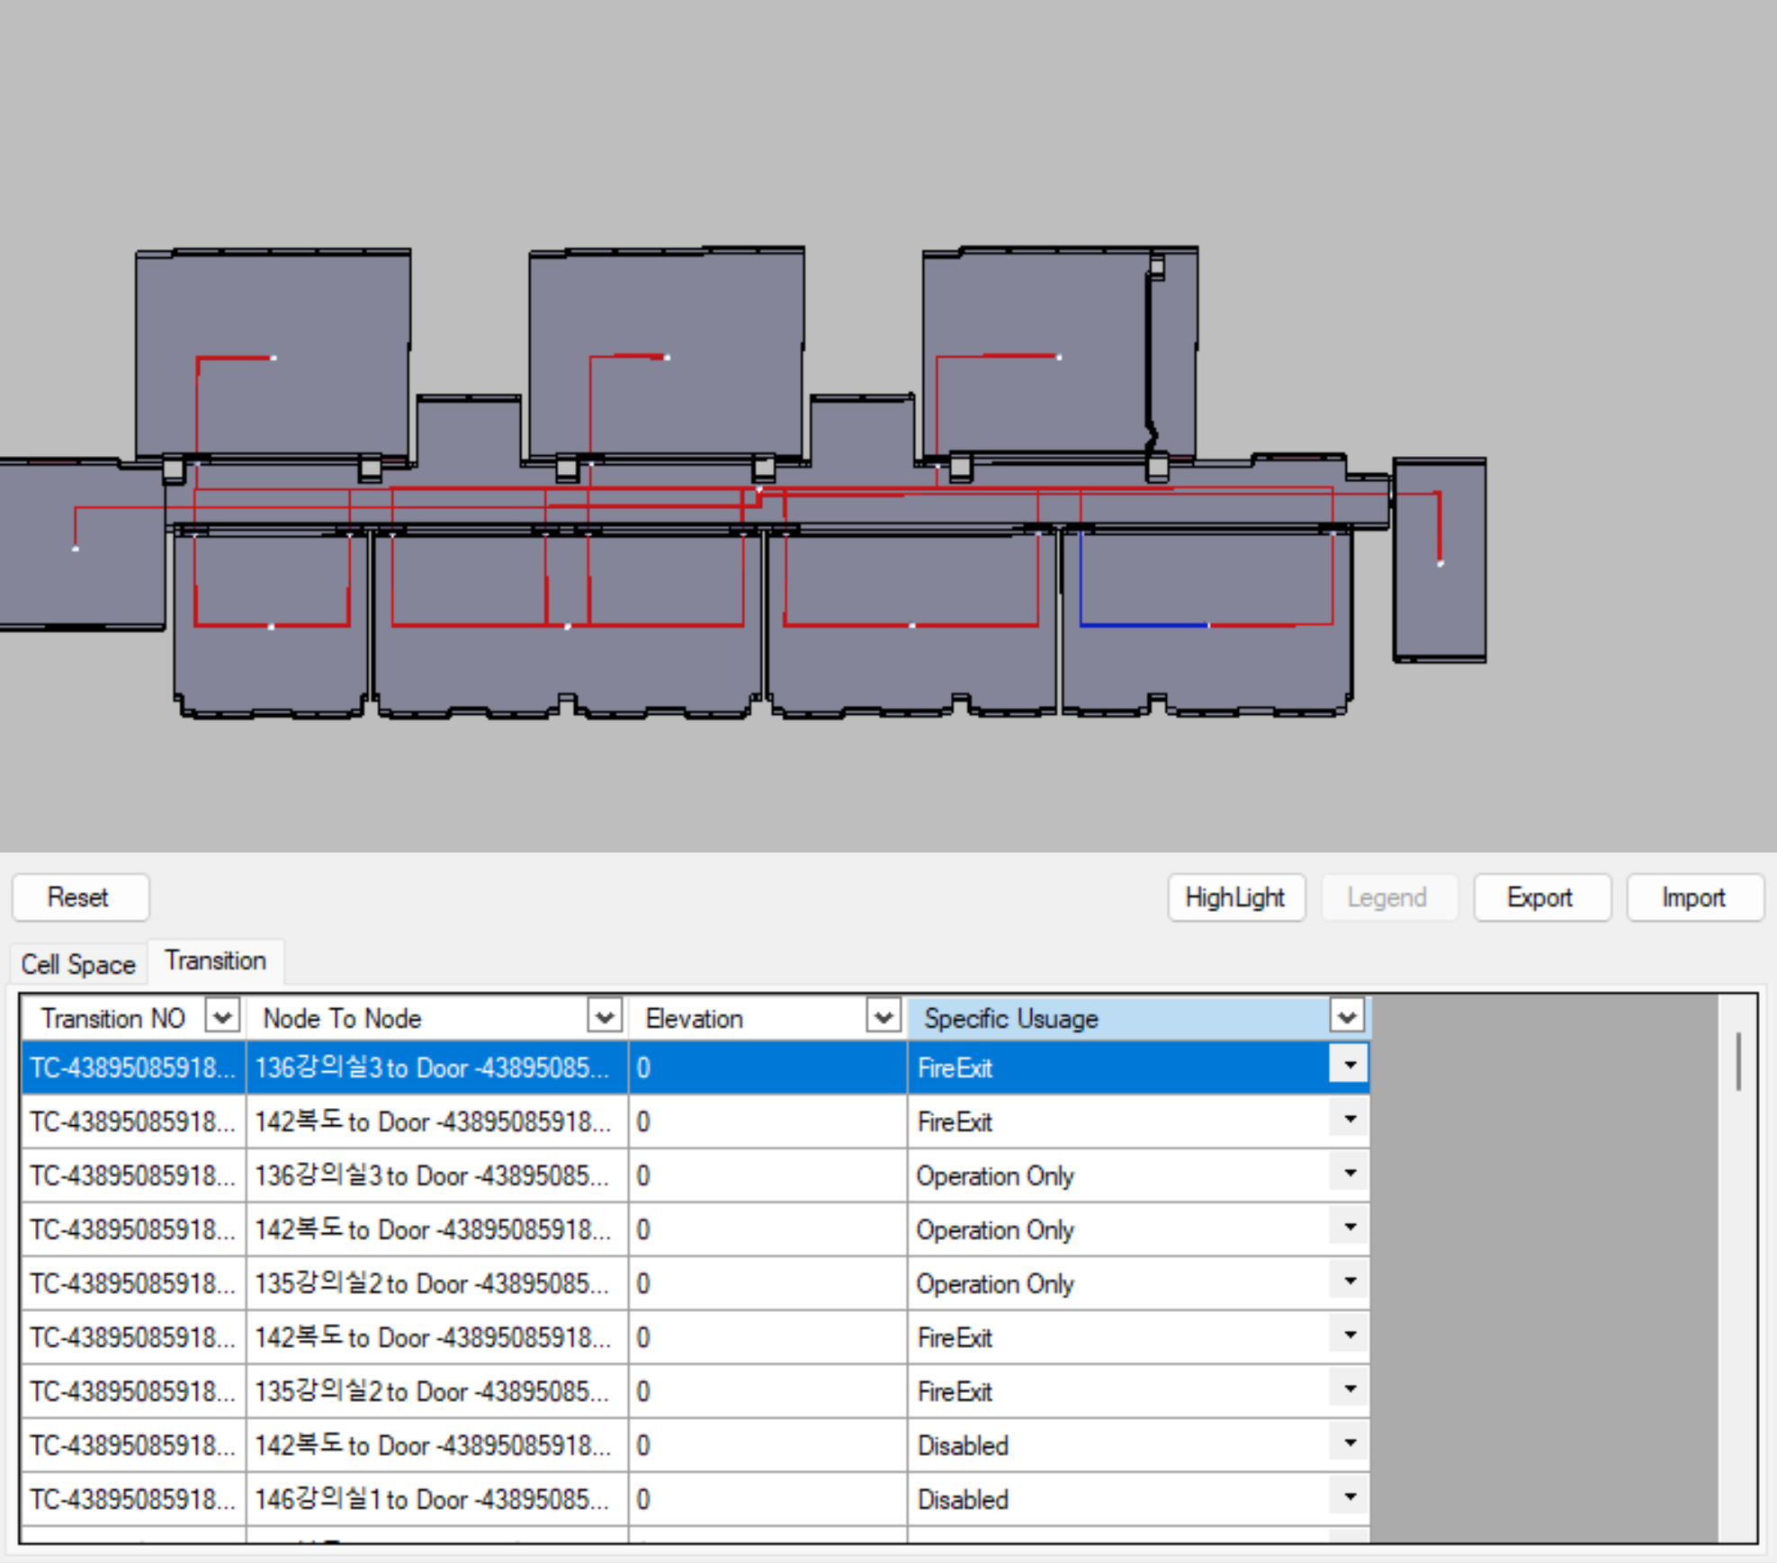

#### Transition Information Excel Export

Just like Cell Space, you can extract it to Excel, then modify it and import it.

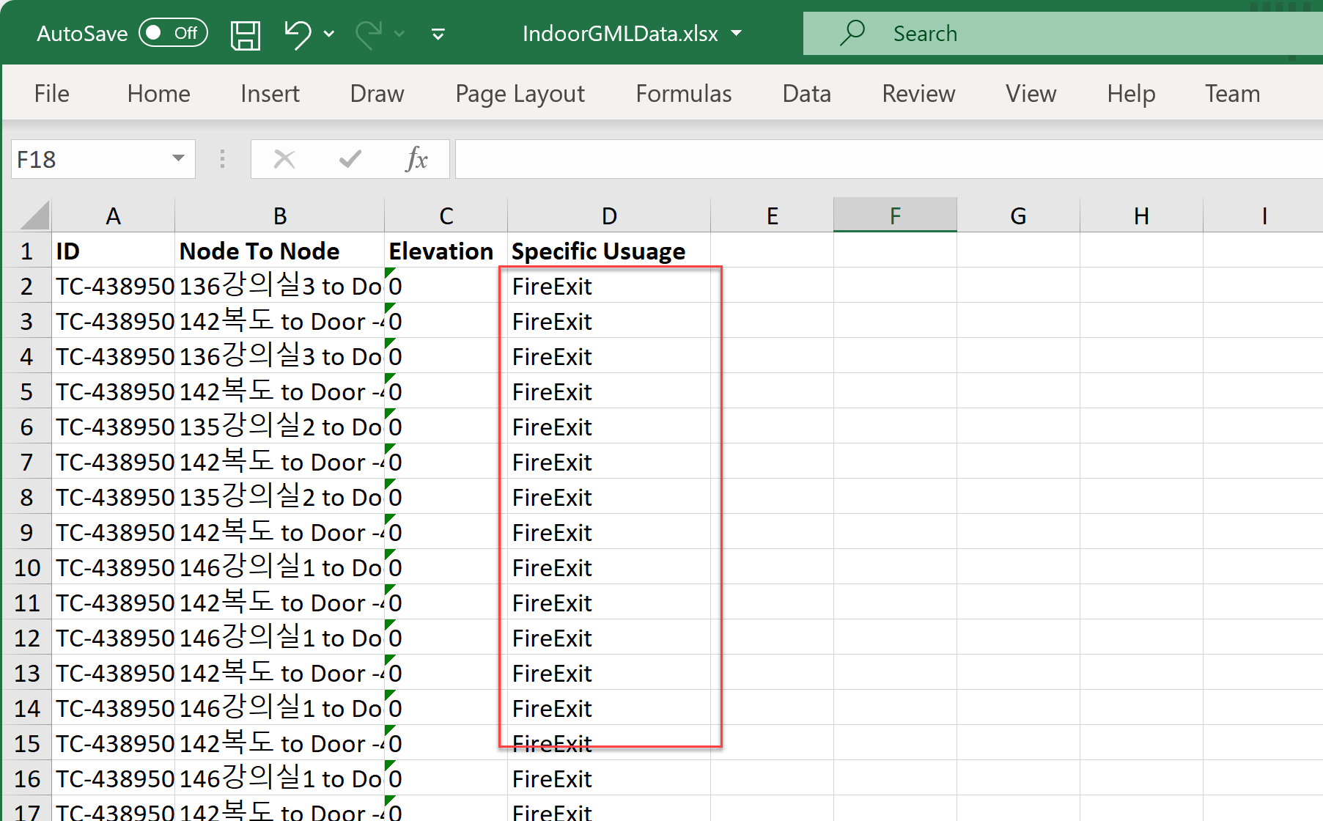

## Guide for Editing exported IndoorGML Excel

Exported excel file includes 5 sheets

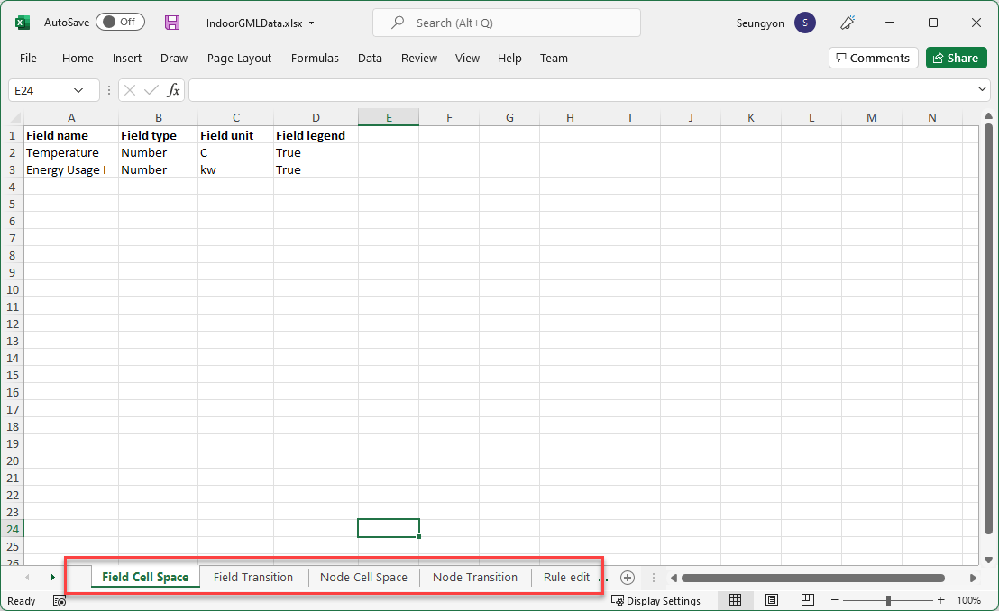

|  |  |  |
| --- | --- | --- |
| Sheet Name | Contents | Remarks |
| Filed Cell Space |  | Cell Space’s custom Filed list for Building Energy Infomraiton |
| Node Cell Space |  | Each Cell Sapce’s Unique ID and Custom Field Data |
| Field Transition |  | Transition’s custom Field |
| Node Transition |  | Each Transition’s Unique ID and Custom Field Data |
| Rule to Edit | Contains Rule to edit.  You can change the Field Name on Field CellSpace and Field Transition sheet, but you need to revisied the field name on Node Cell Space and Node Transition sheets also. |  |

# Considerations

1. If the coordination is different for each floor, it will not be combined into a single building. In this case, after setting the same reference coordinate point for each CAD drawing, creating a GML file for each layer again, and then combining them.
2. If two layers are created in one drawing, firstly separate drawings for each floor for IndoorGML extraction.